­­



Submitted to

:

Sir. Niaz Muhammad

***BS-Software Engineering 4th-E***

Title: LAB REPORTS

OS(Linux)

Hamza Mehmood

Roll# SP-21-110

NUML-S21-23530



National University of Modern Languages

OPERATING SYSTEMS (Linux)

# LAB 1

**Objective:**

Objective of this lab is to give some background of Linux

* Introduction to Linux
* Introduction to file system
* Advantages of Linux

**Topics discussed:**

* Introduction to Linux
* Advantages of Linux

**Introduction to Linux:**

“LINUX is an operating system or a kernel distributed under an open-source license. Its functionality list is quite like UNIX”.

The kernel is a program at the heart of the Linux operating system that takes care of fundamental stuff, like letting hardware communicate with software.

Linux is an operating system or a kernel which germinated as an idea in the mind of young and bright Linus Torvalds when he was a computer science student. He used to work on the UNIX OS (proprietary software) and thought that it needed improvements.

However, when his suggestions were rejected by the designers of UNIX, he thought of launching an OS which will be receptive to changes, modifications suggested by its users.

**Advantages of Linux:**

The overall benefit of Linux is that;

* Its open source, which means its source code, is accessible to anyone who wants it.
* Anyone with the ability to code can contribute, modify, enhance, and distribute Linux for any intended use.
* Linux has a huge online community with vast numbers of forums providing support and sharing knowledge extensively.

**Linux Command Line:**

The shell is where commands are invoked

A command is typed at a shell prompt

* Prompt usually ends in a dollar sign ($)

After typing a command press Enter to invoke it

* The shell will try to obey the command

Another prompt will appear

### **ls command:**

The**ls** command is used to view the contents of a directory. By default, this command will display the contents of your current working directory.

If you want to see the content of other directories, type **ls** and then the directory’s path. For example, enter **ls** **/home/username/Documents** to view the content of **Document.**

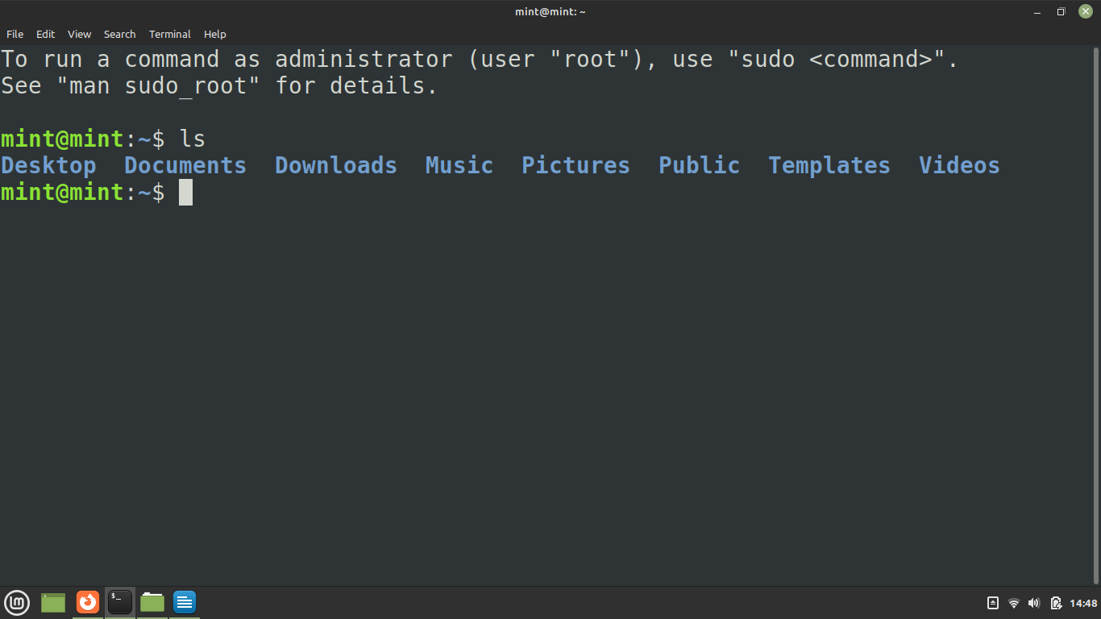

### **cd command:**

To navigate through the Linux files and directories, use the **cd** command. It requires either the full path or the name of the directory, depending on the current working directory that you are in.

Let’s say you’re in **/home/username/Documents** and you want to go to **Photos**, a subdirectory of **Documents**. To do so, simply type the following command: **cd** **Photos**.

There are some shortcuts to help you navigate quickly:

* **cd ..** (with two dots) to move one directory up
* **cd**to go straight to the home folder
* **cd-** (with a hyphen) to move to your previous directory

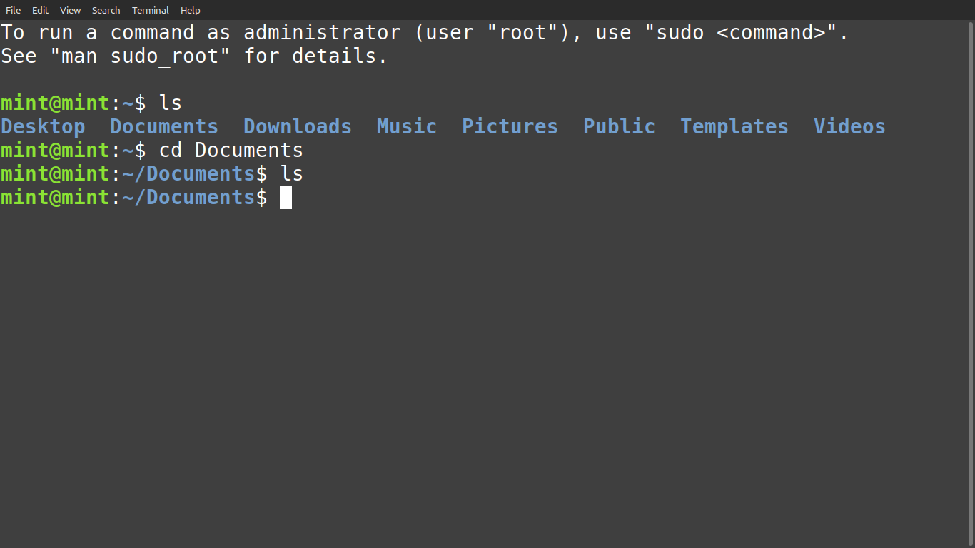

# LAB 2

### [**cat command**](https://www.hostinger.com/tutorials/linux-cat-command-tutorial-and-examples/)**:**

**cat** (short for concatenate) is one of the most frequently used commands in Linux. It is used to list the contents of a file on the standard output (sdout). To run this command, type **cat** followed by the file’s name and its extension. For instance: **cat file.txt**.

Here are other ways to use the **cat** command:

* **cat > filename**creates a new file

### [**touch command**](https://www.hostinger.com/tutorials/linux-touch-command-with-useful-examples/)**:**

The **touch** command allows you to create a blank new file through the Linux command line. As an example, enter touch **/home/username/Documents/Web.html** to create an HTML file entitled **Web** under the **Documents** directory.

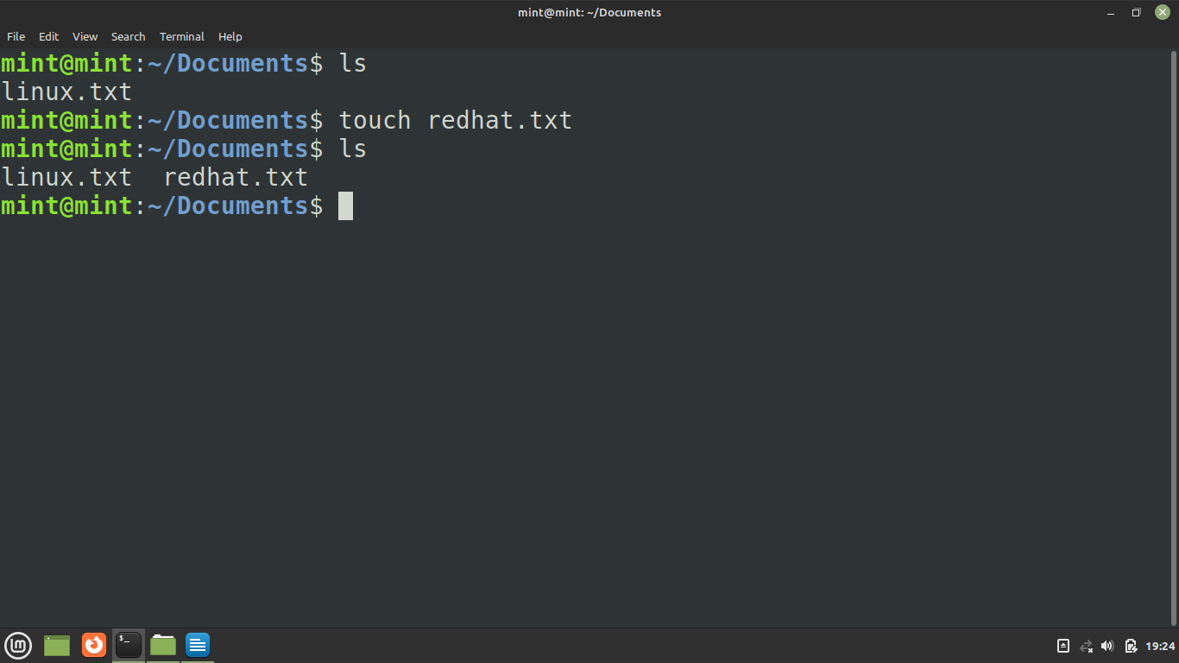

### **cp command:**

### Use the **cp** command to copy files from the current directory to a different directory. For instance, the command **cp scenery.jpg** **/home/username/Pictures** would create a copy of **scenery.jpg** (from your current directory) into the **Pictures** directory.

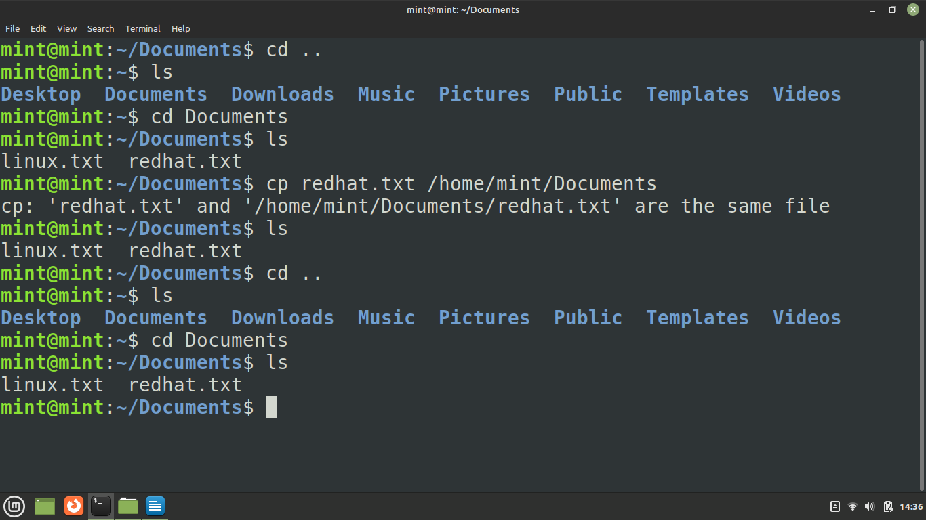

### [**mv command**](https://www.hostinger.com/tutorials/how-to-rename-files-in-linux/)**:**

The primary use of the **mv** command is to move files, although it can also be used to rename files.

The arguments in mv are similar to the cp command. You need to type **mv**, the file’s name, and the destination’s directory. For example: **mv file.txt /home/username/Documents**.

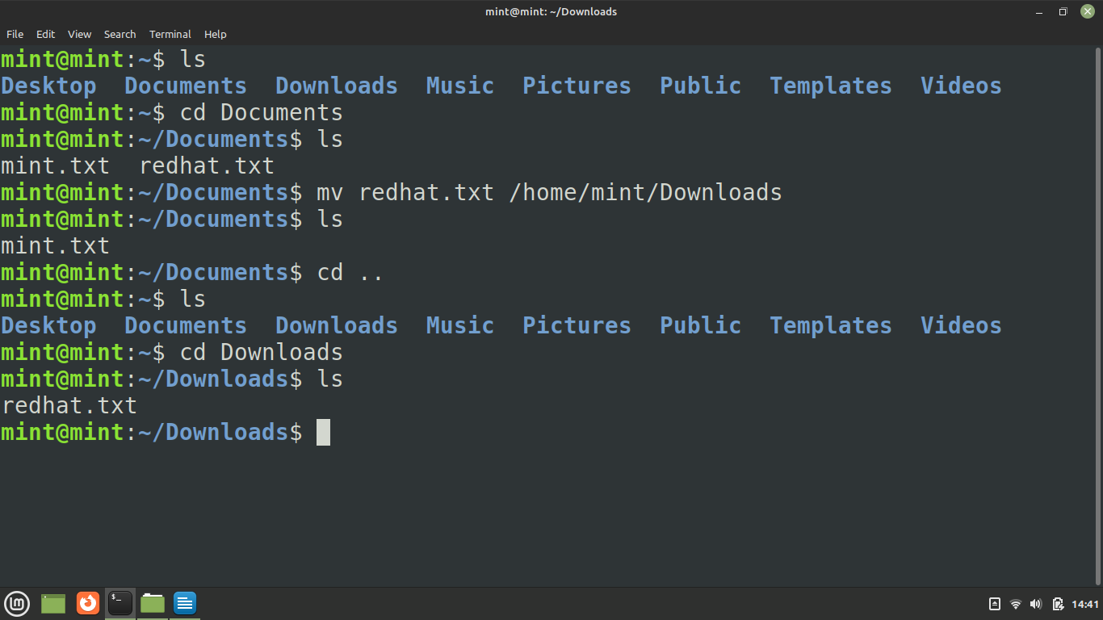

To rename files, the Linux command is **mv oldname.ext newname.ext**

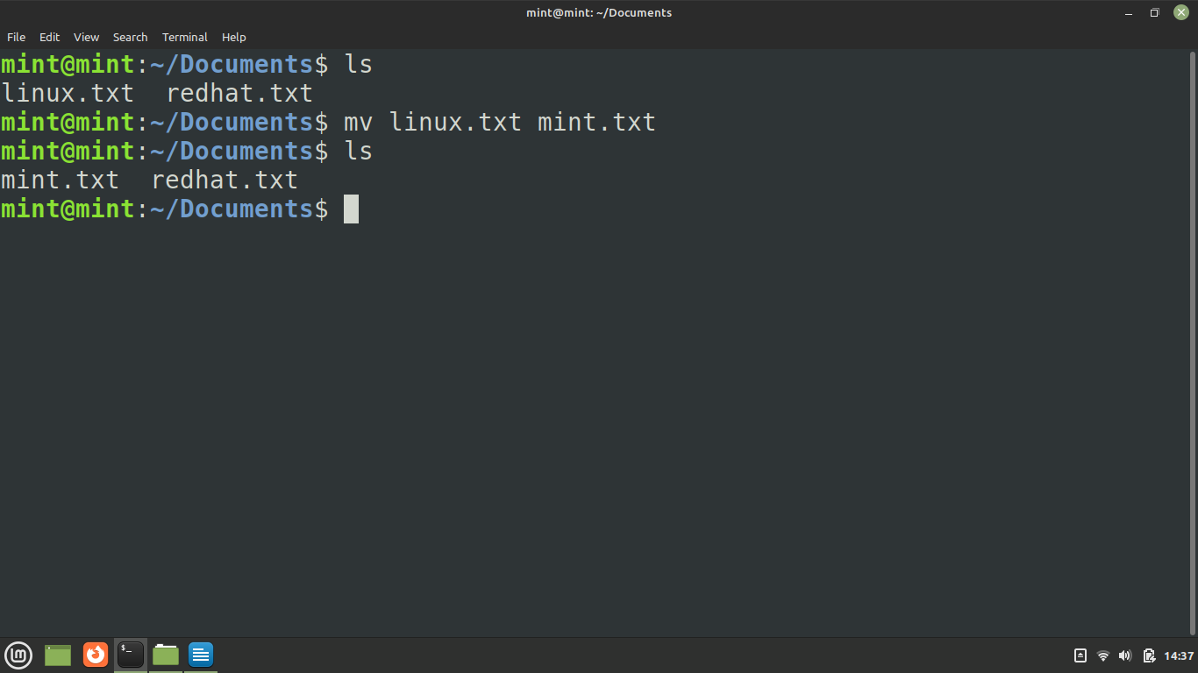

### **mkdir command:**

Use **mkdir** command to make a new directory — if you type **mkdir Music** it will create a directory called **Music**.

There are extra **mkdir** commands as well:

* To generate a new directory inside another directory, use this Linux basic command **mkdir Music/Newfile**

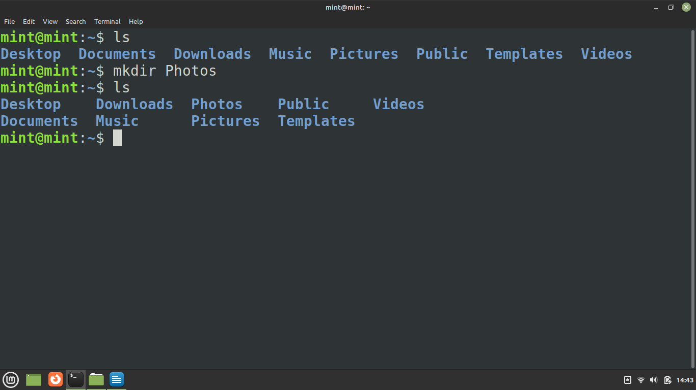

### **rm & rmdir command:**

The **rm** command is used to delete directories and the contents within them.

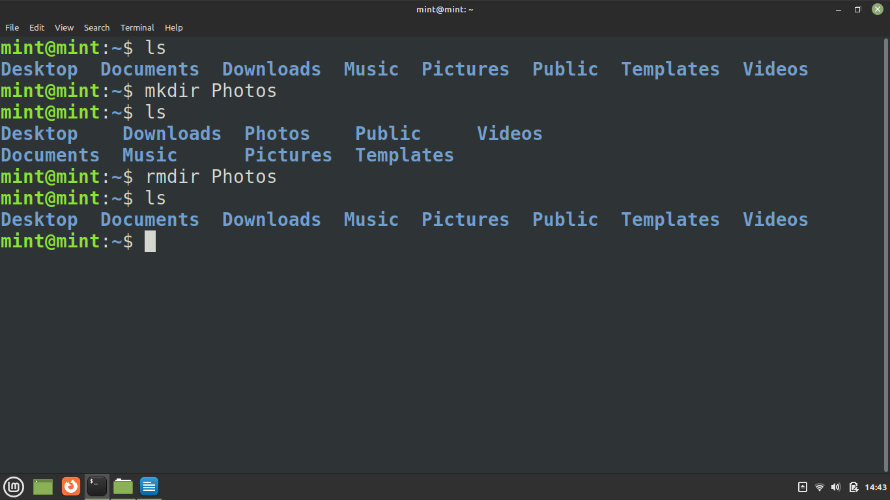

# LAB 3

### **pwd command:**

**pwd** command tells us the current directory we are in

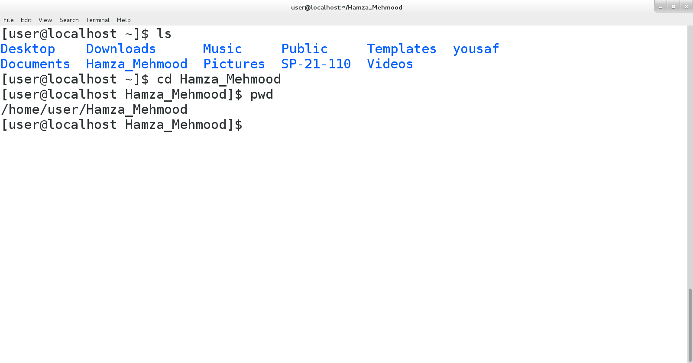

**Ls –a command:**

**ls –a command** shows us the hidden directories in linux:

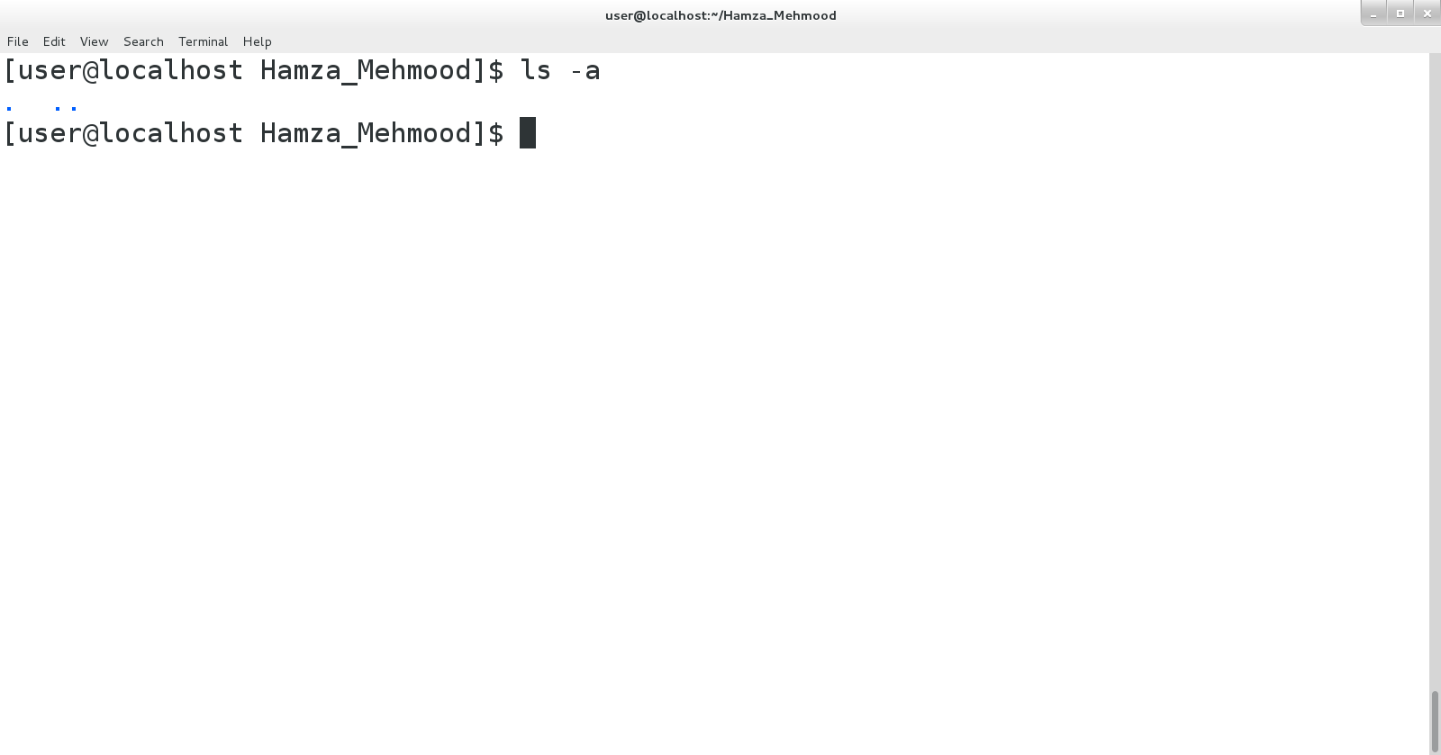

**Locate command:**

**locate** filename command shows the file path or where this file/directory is located.

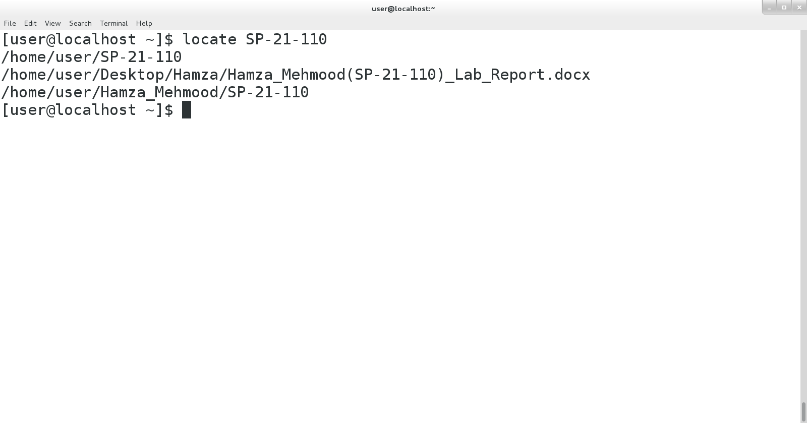

**cd ~ command:**

**cd ~ command** takes us to the user directory:

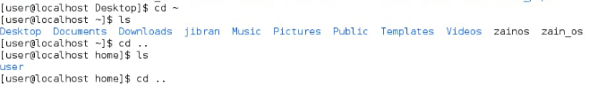

**Relative Path:**

Relative path is defined as the path related to the present working directly(pwd). It starts at your current directory and never starts with a / .

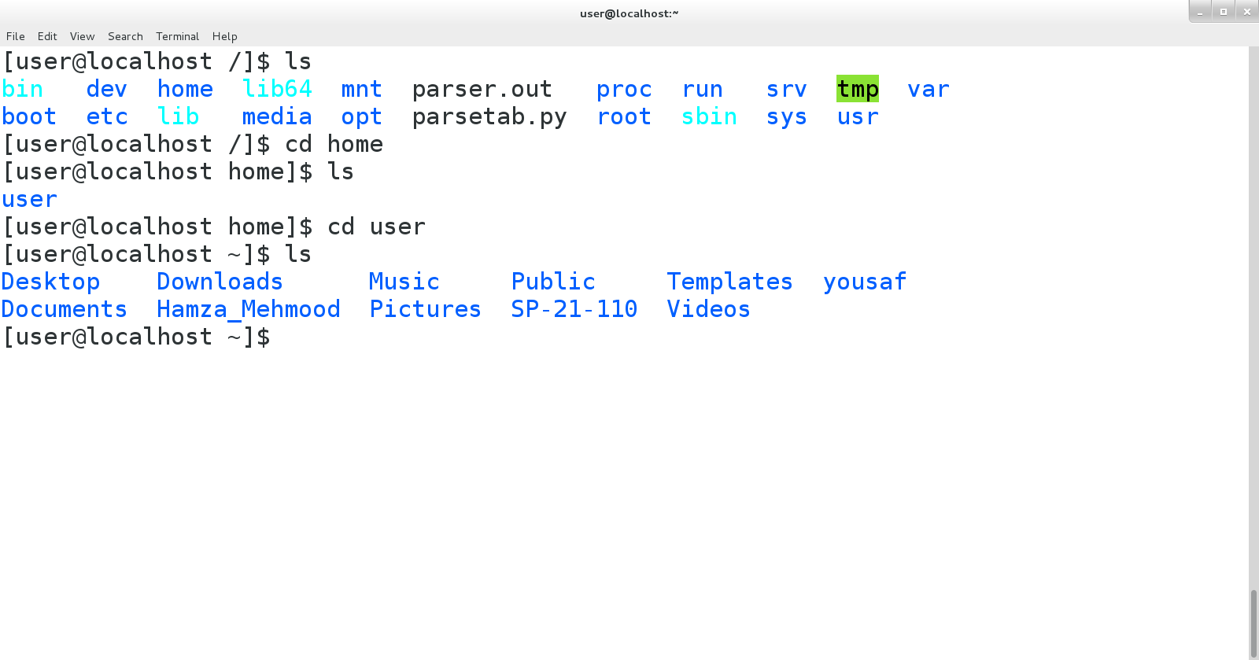

**Absolute Path:**

An absolute path is defined as the specifying the location of a file or directory from the root directory(/).

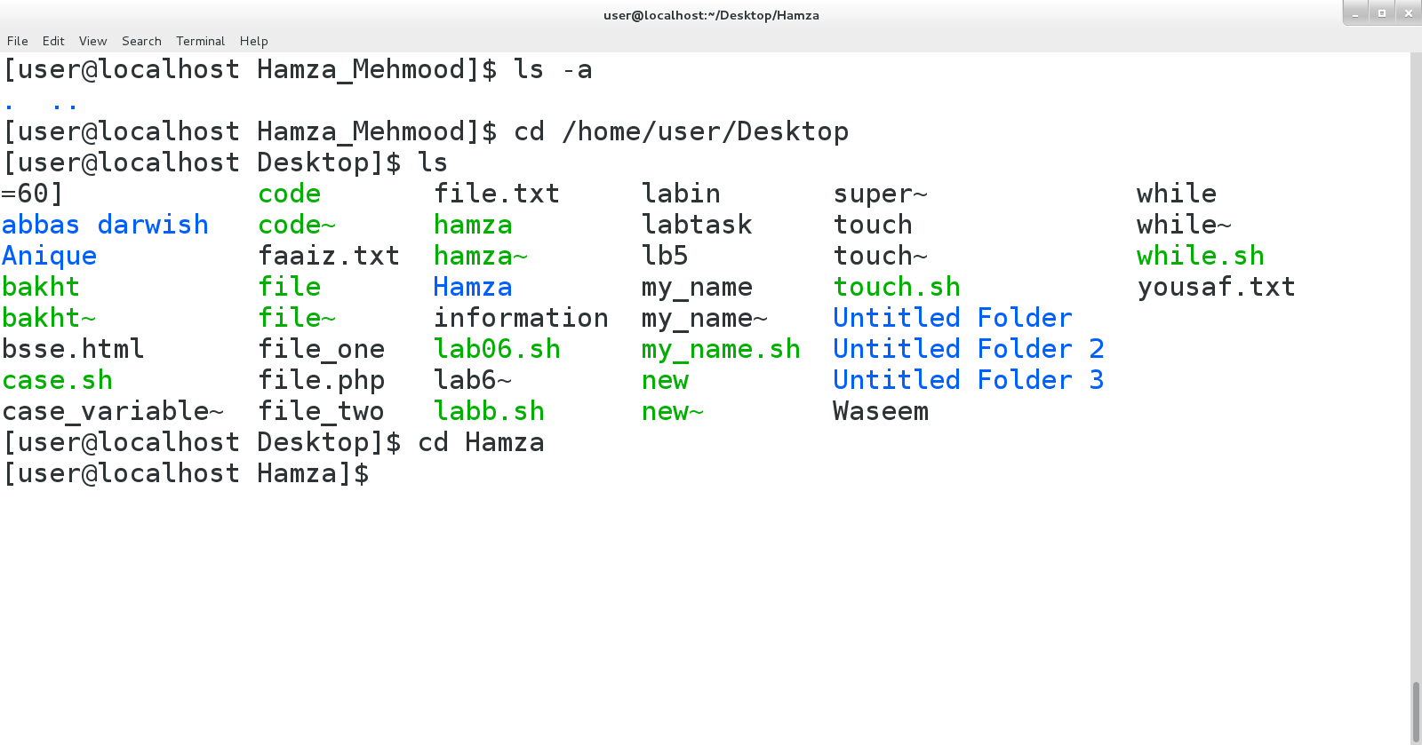

**ls -1 Command:**

Used to show the Files/Folders on Which the Modification has been Done.

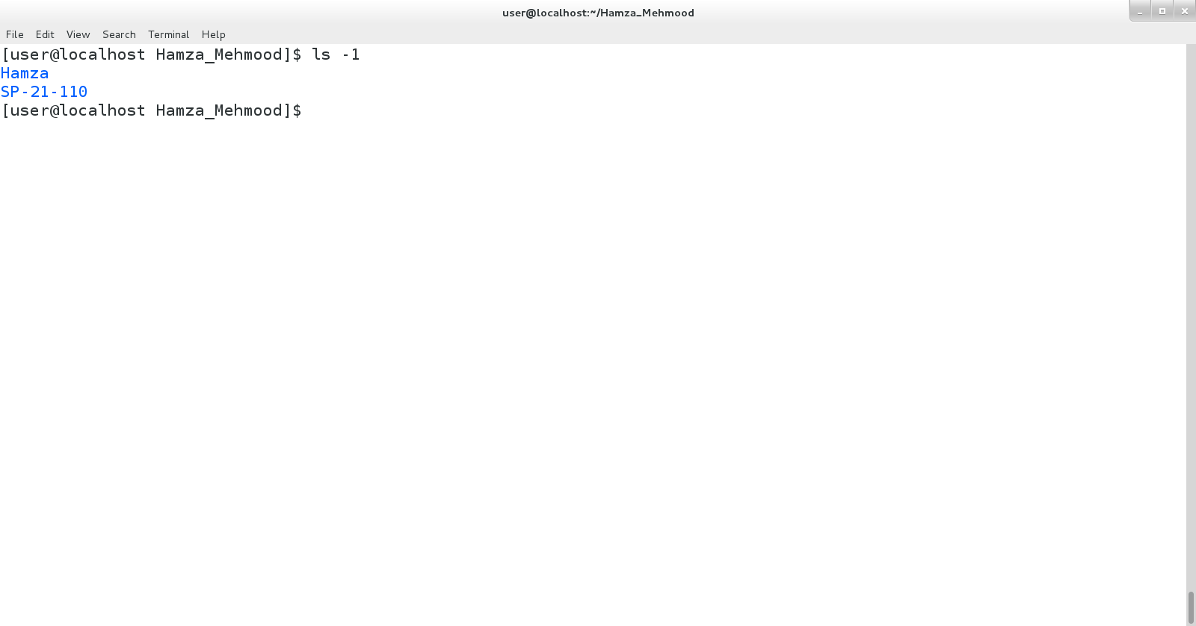

# LAB 4

**ls -1 Command:**

The ls command is one of the basic commands that any Linux user should know. It is used to list information about files and directories within the file system.

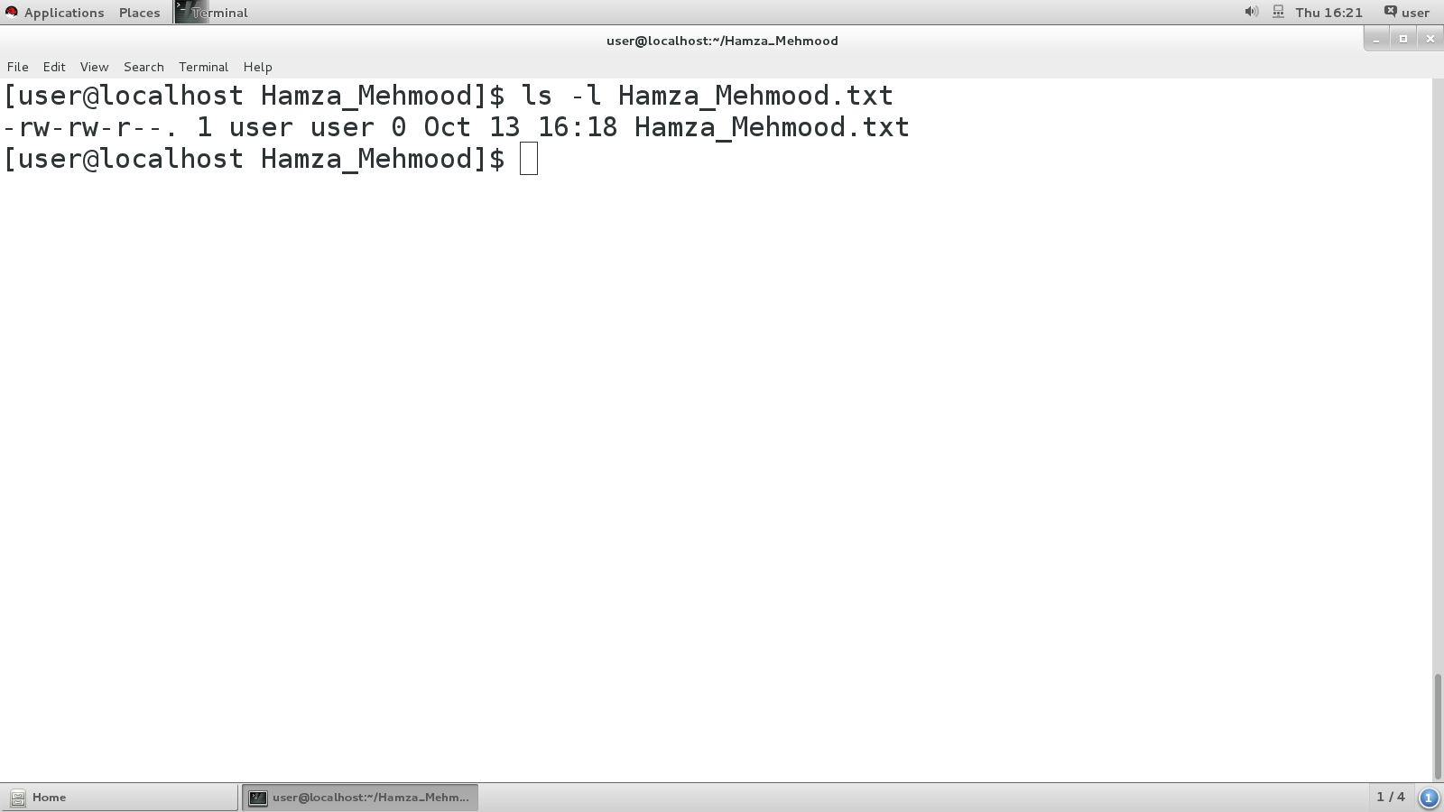

**echo $Lmn command:**

is used to print the text or string to the shell or output file.

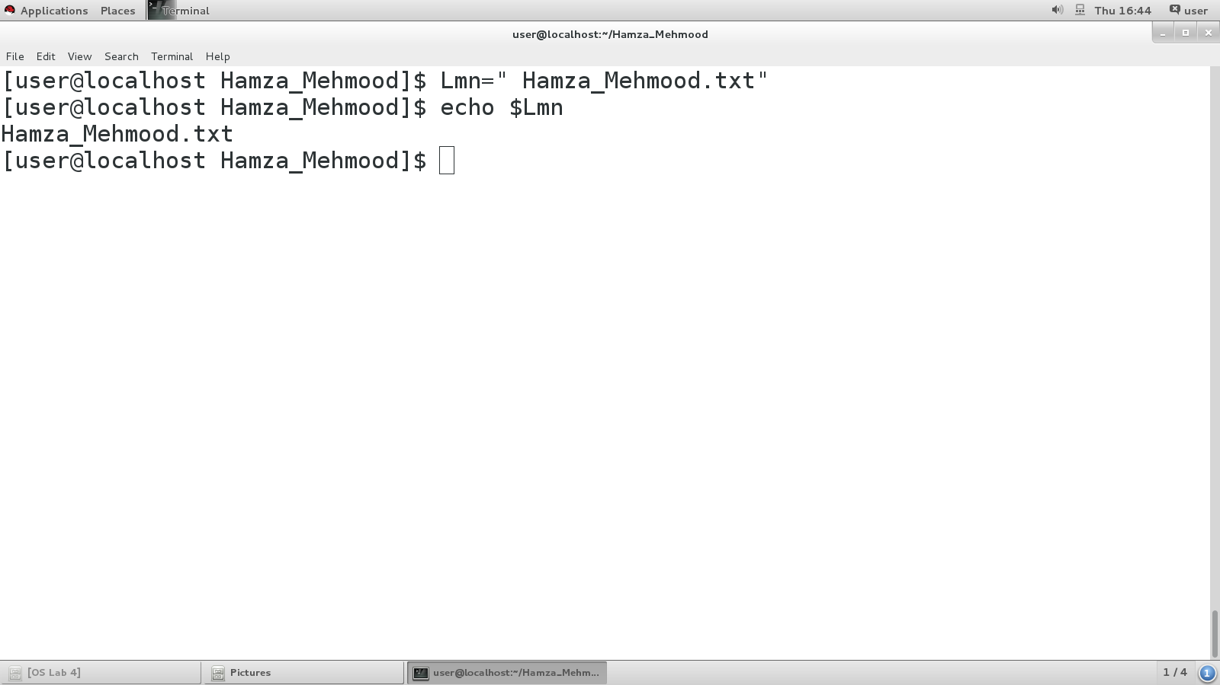

**rm !$ command:**

Basically, it's the last argument to the previous command. !$ is the "end" of the previous command which is used to remove the last executed command.

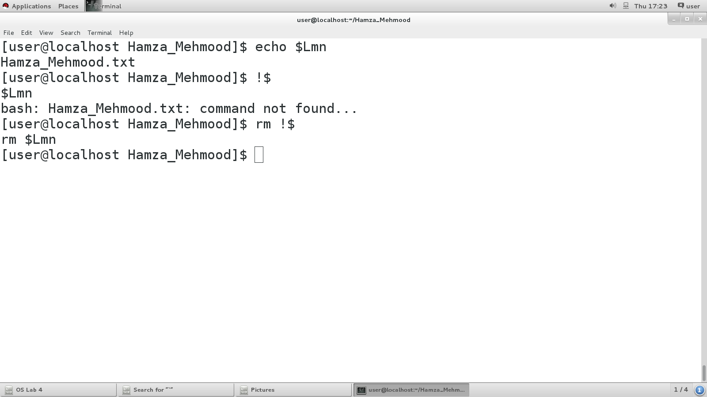

**!! Command:**

is used to display the last executed command along with it's Output/stored Value.

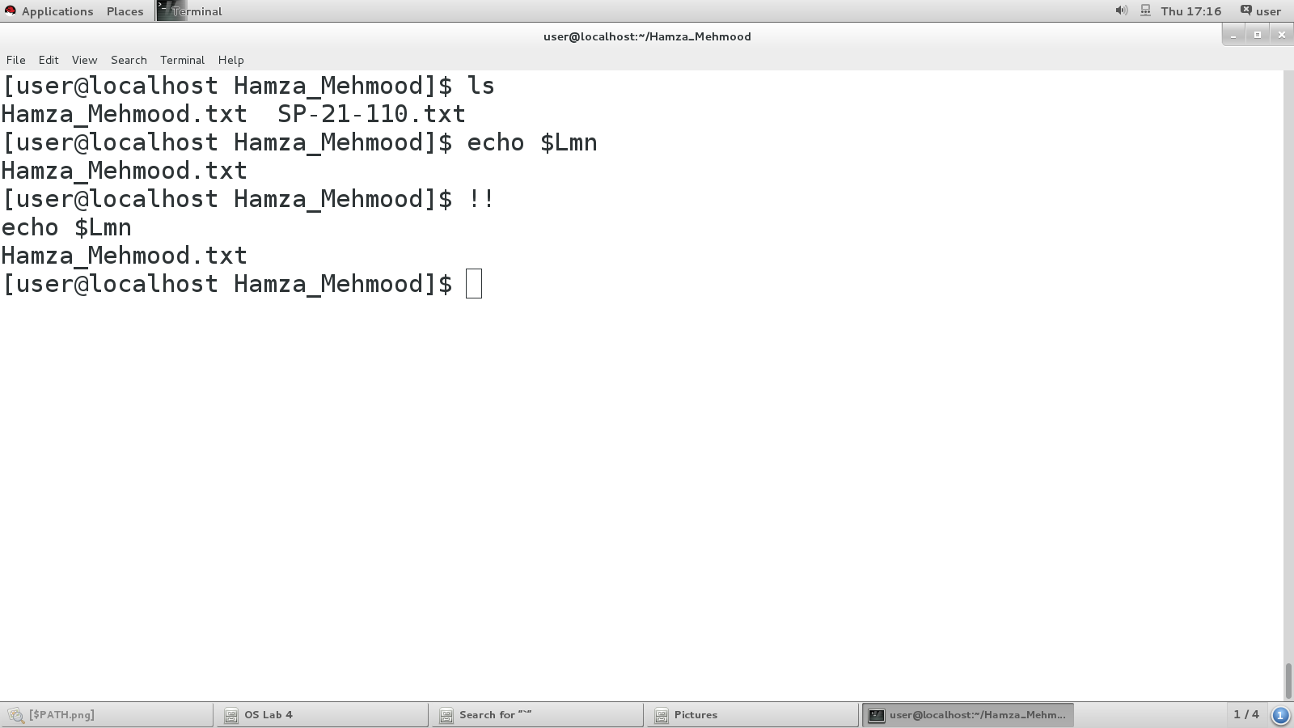

**echo $path command:**

used to find which directories your shell is set to check for executable files. This output is a list of directories where executable files are stored.

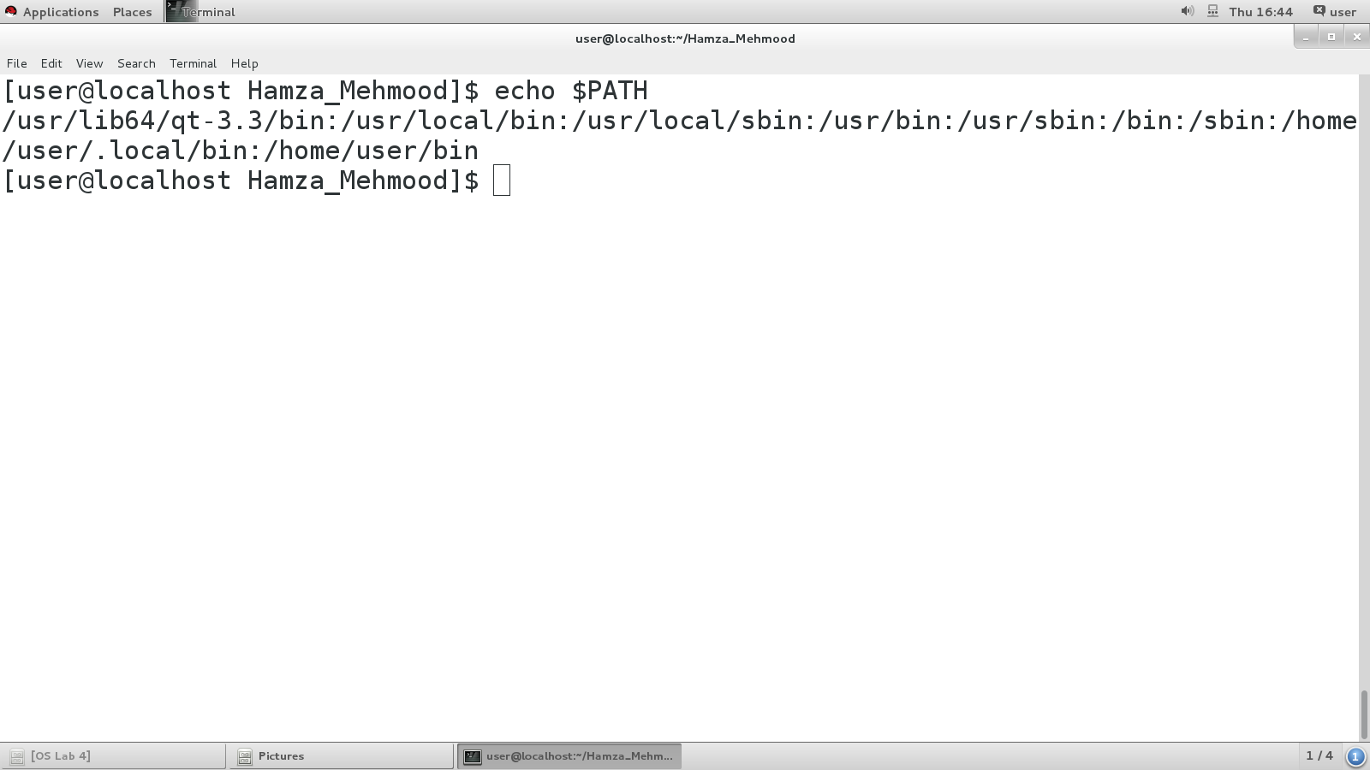

**echo $ps1 command**

It's the format string for your prompt

\u = user

\h = hostname

\W = working directory

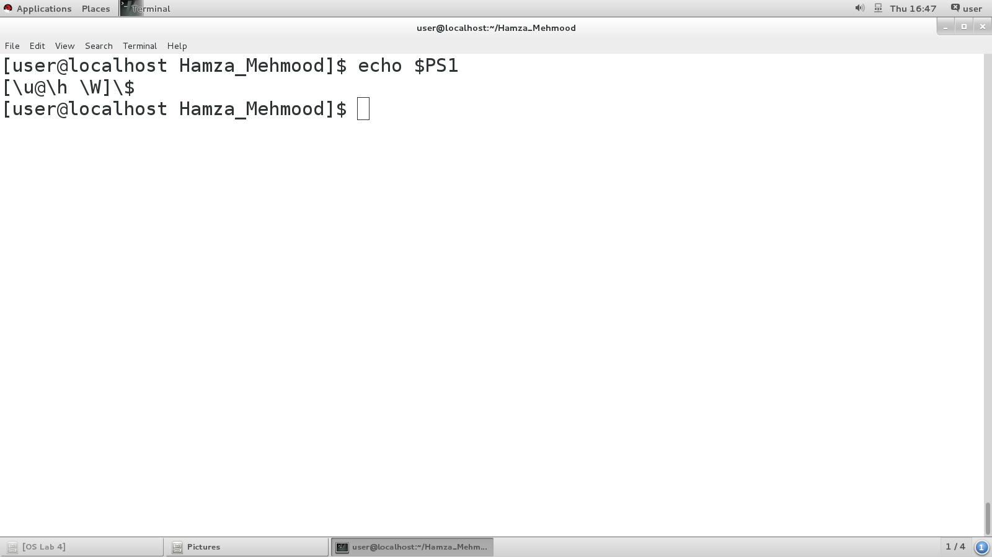

**ls -l -a command**

used to display the information of all files in current directory along with hidden files as well.

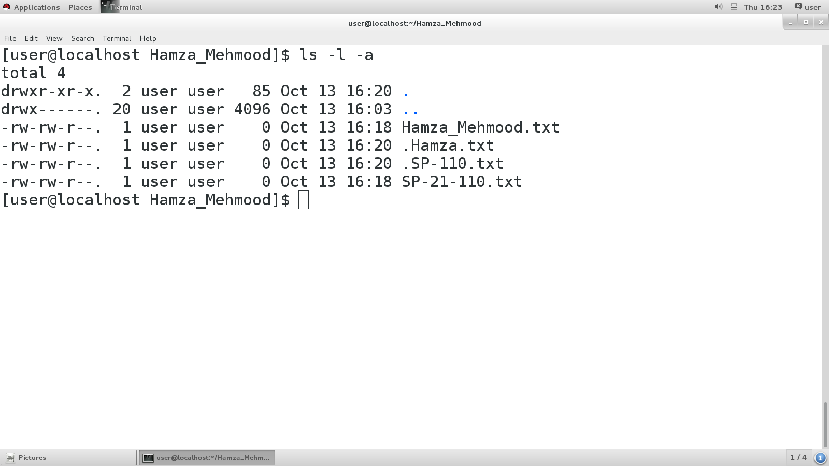

**ls -l * filename command**

used to display the information of all files in current directory.

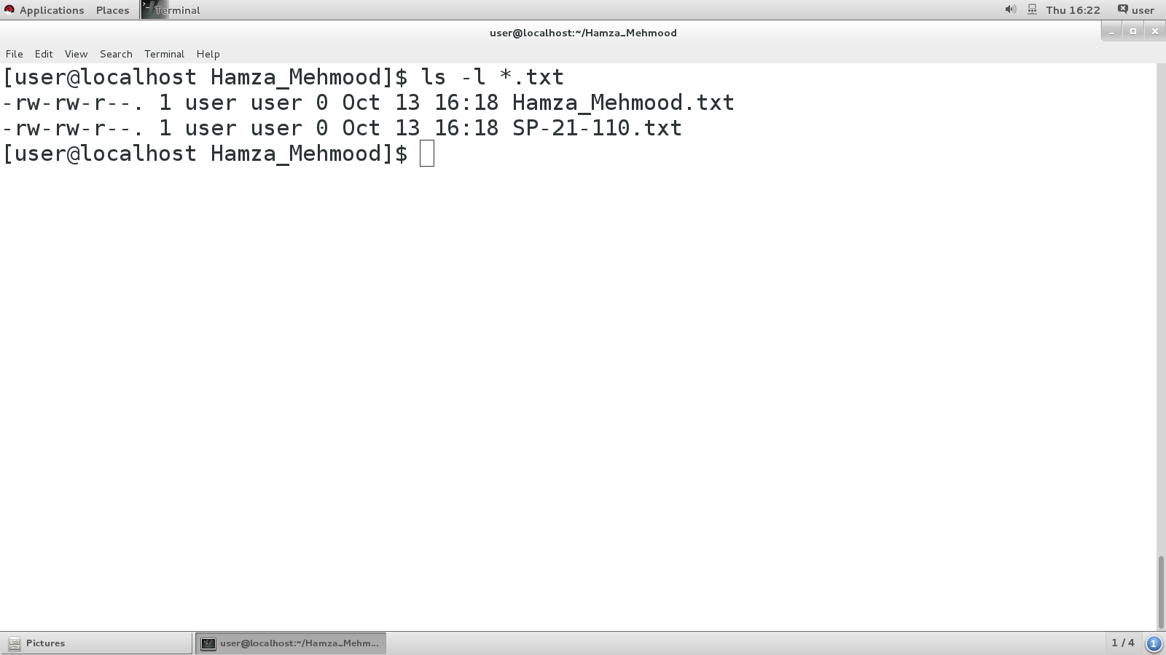

**!$ command:**

Used to Display the last executed Command on Terminal.

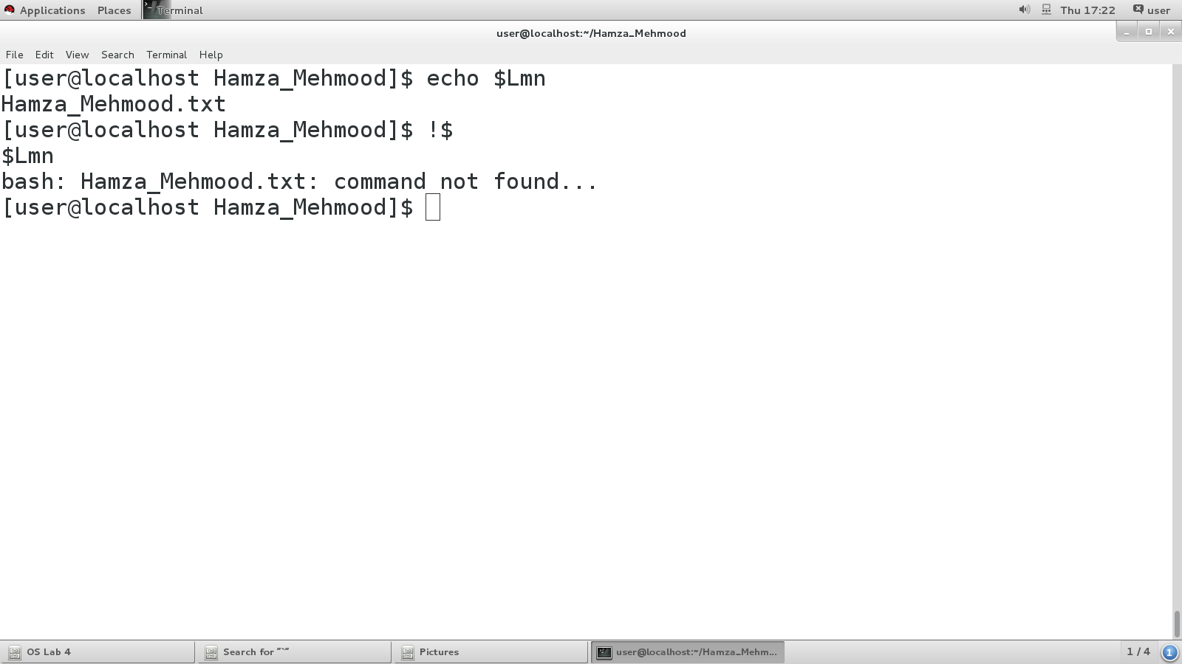

# LAB 5

**ls –l $(locate manual.html) command:**

This command is used to list all files in the current directory.

And to display there long listing detailed information.

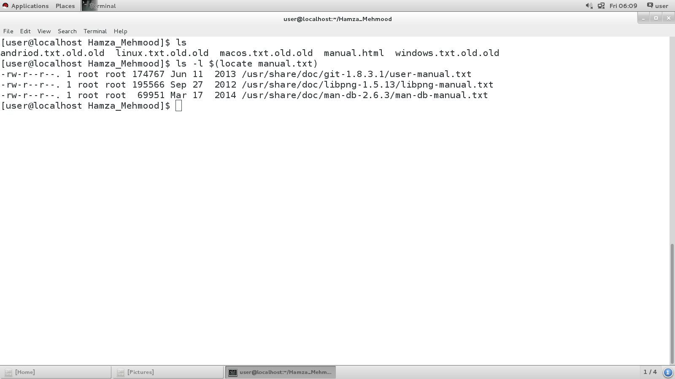

**find –name manual.html command:**

The find command in linux is a command line utility for walkig a file hierarchly. It can be used to find files and directories and perform subsequent operations on them. It supports searching by file, folder, name, creation date, owner and premissions.

If you need to know how to find a file in Linux called thisfile.txt, it will look for it in current and sub-directories.

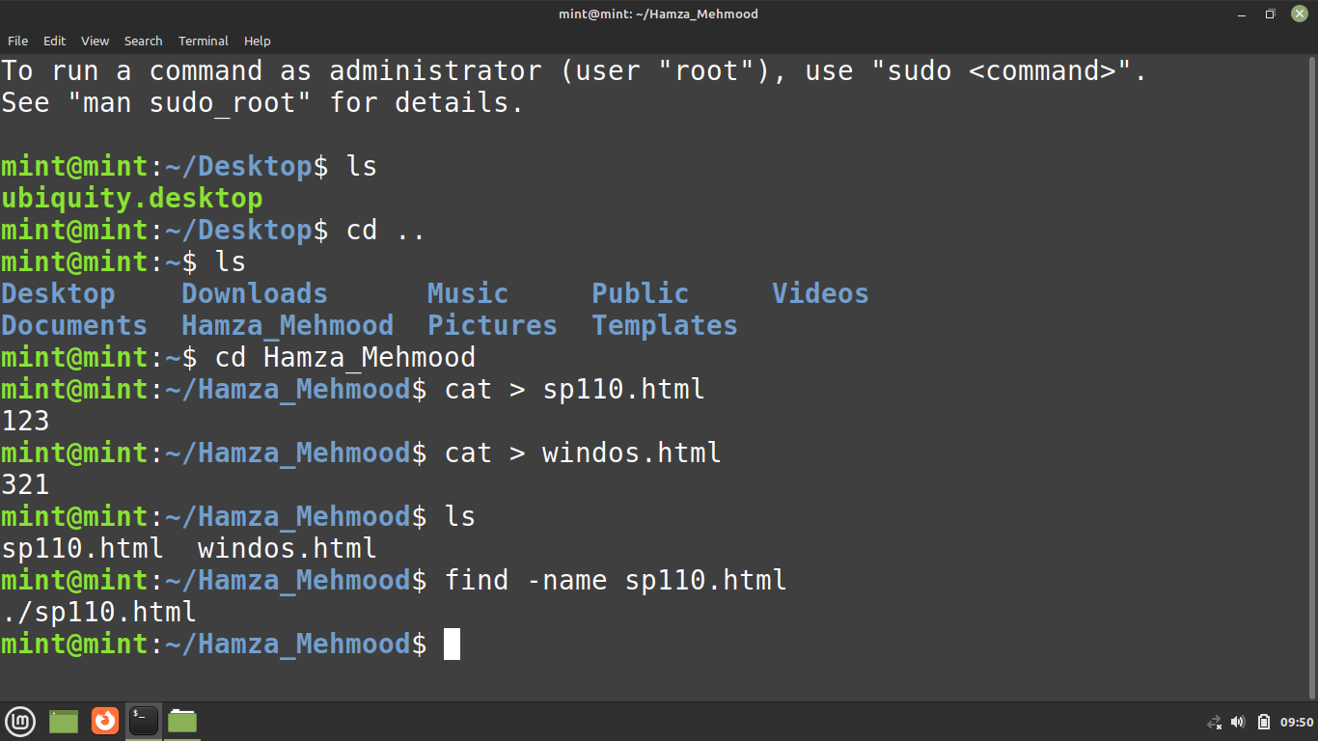

**for loop command:**

making .txt files and displaying them by using a for loop command as “file.txt.old”.

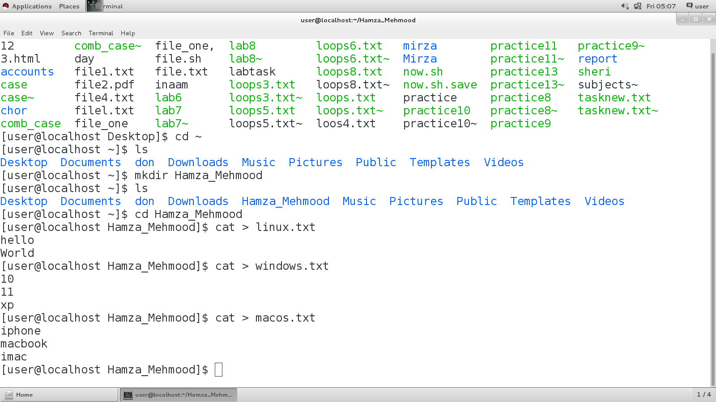

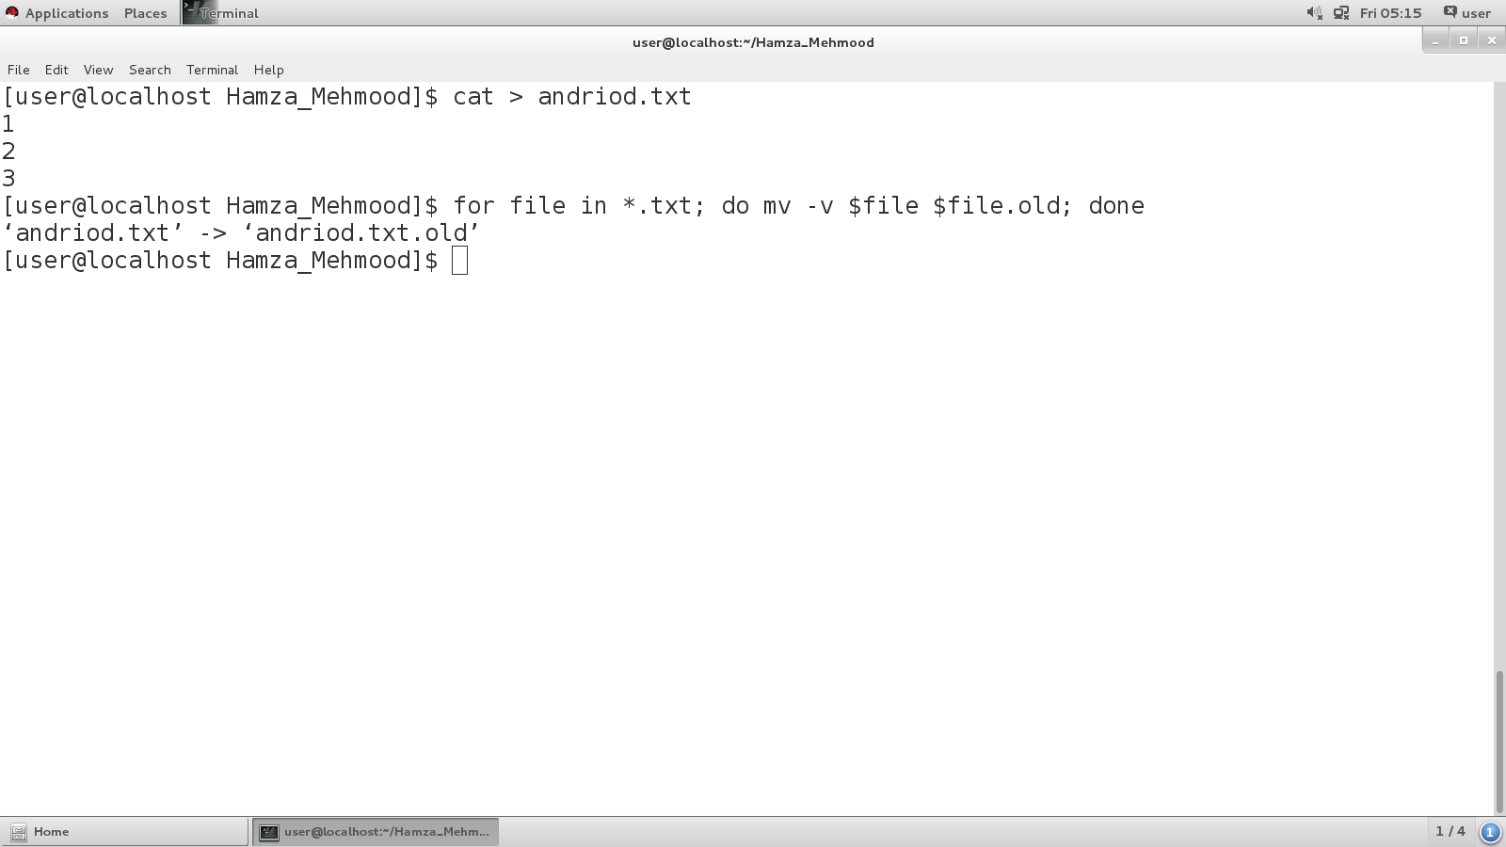

**Removing .txt files:**

Removes the .txt file by the order we mention in by using rm –v command.

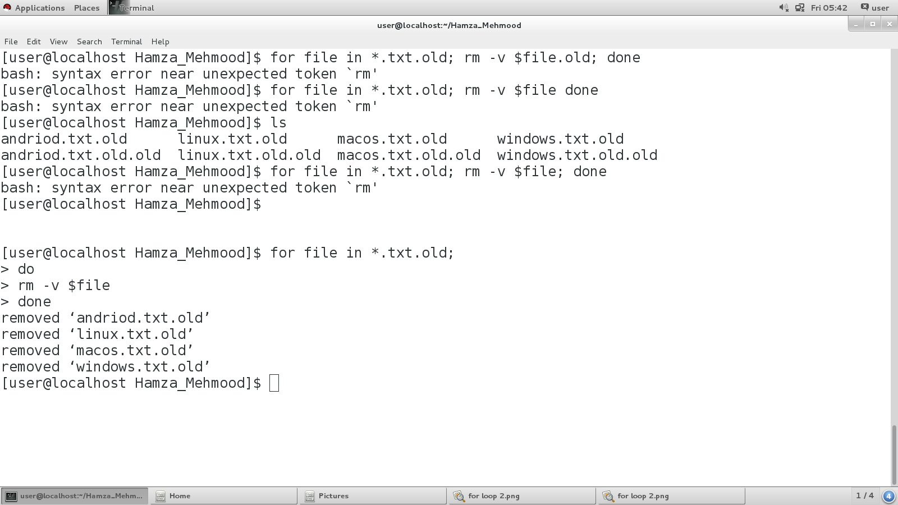

**ls –l ‘manual.html’ command:**

This command is used to list information about files and directories within the current file system.

**Copying txt files:**

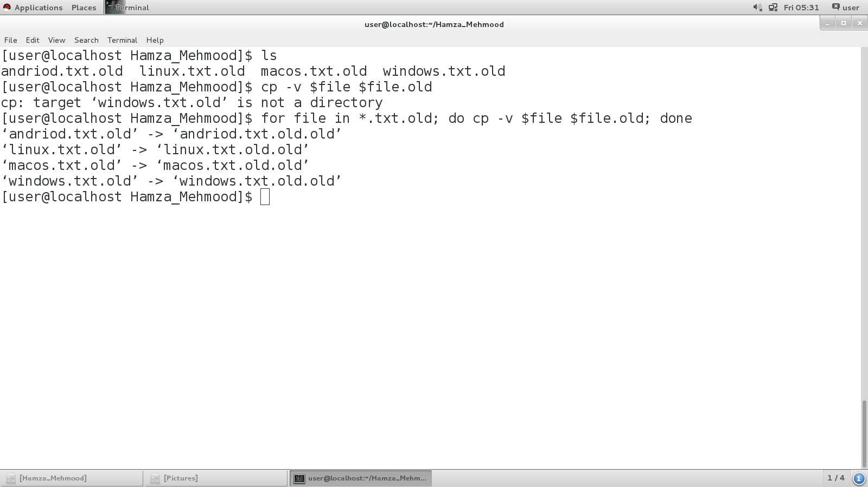

**ls –l $(locate manual.html | tail -1) command:**

The tail [command](http://www.linfo.org/command.html) reads the final few lines of any text given to it as an input and writes them to [standard output](http://www.linfo.org/standard_output.html) (which, by default, is the monitor screen).

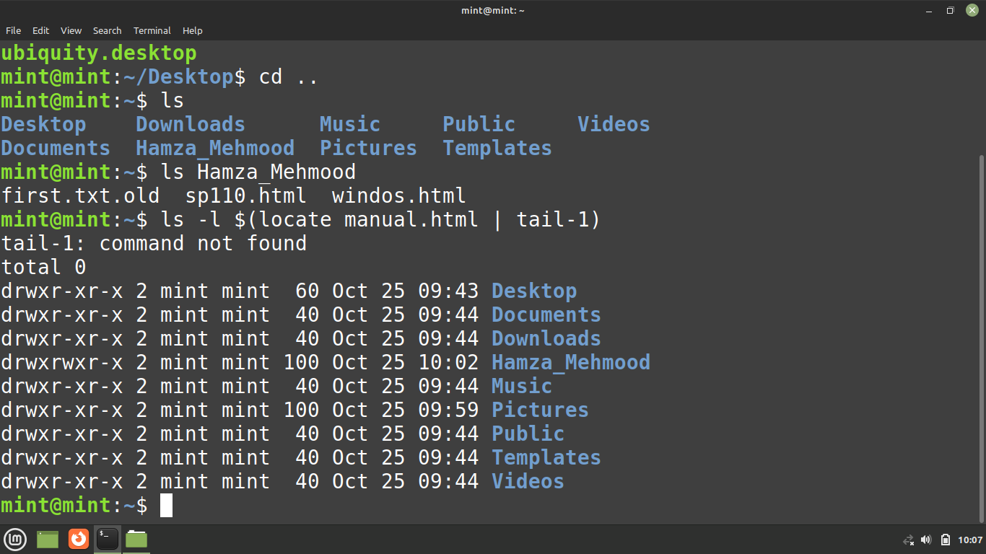

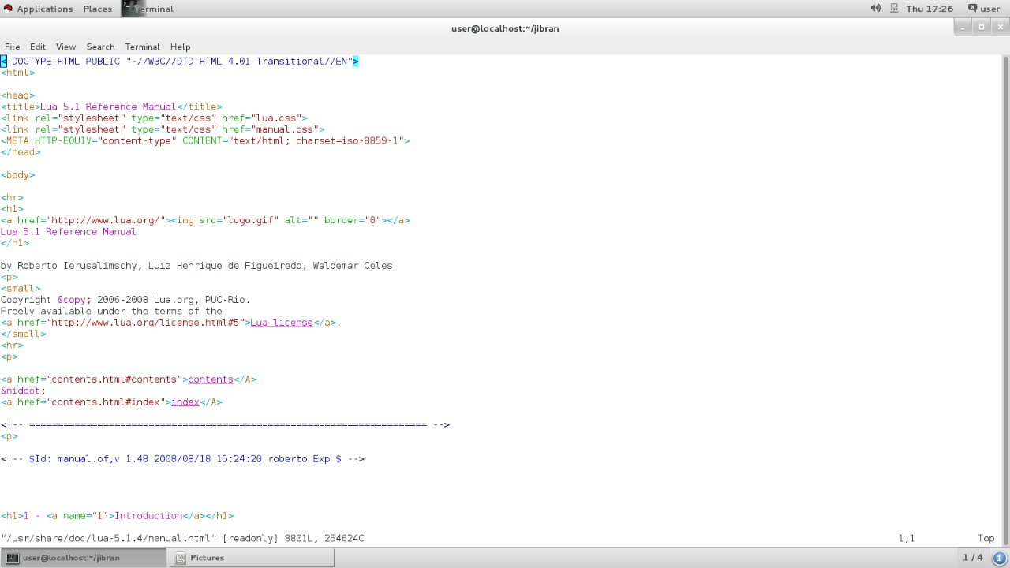

# LAB 6

**Push & Pop command:**

Both pushd and popd are shell builtin commands. **The pushd command is used to save the current directory into a stack and move to a new directory**. Furthermore, popd can be used to return back to the previous directory that is on top of the stack.

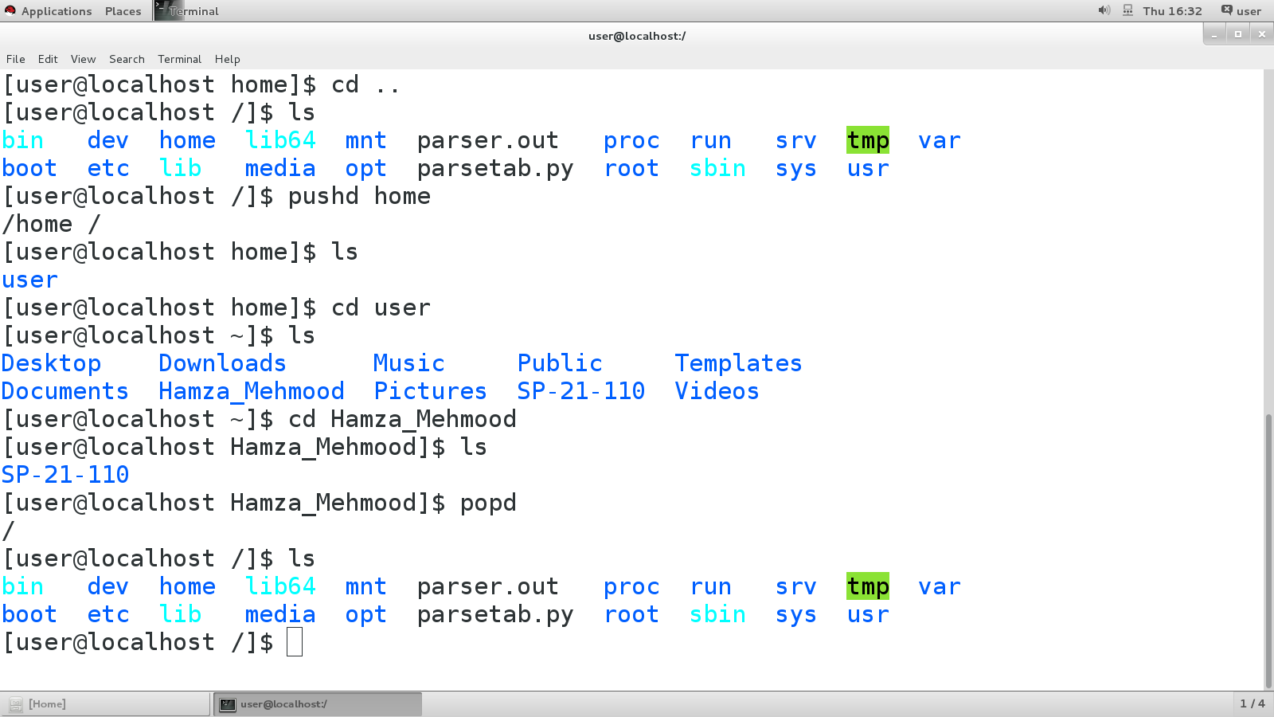

**-p (Auto Directory) command:**

This command is used to make auto Directories AS mentioned by the user.

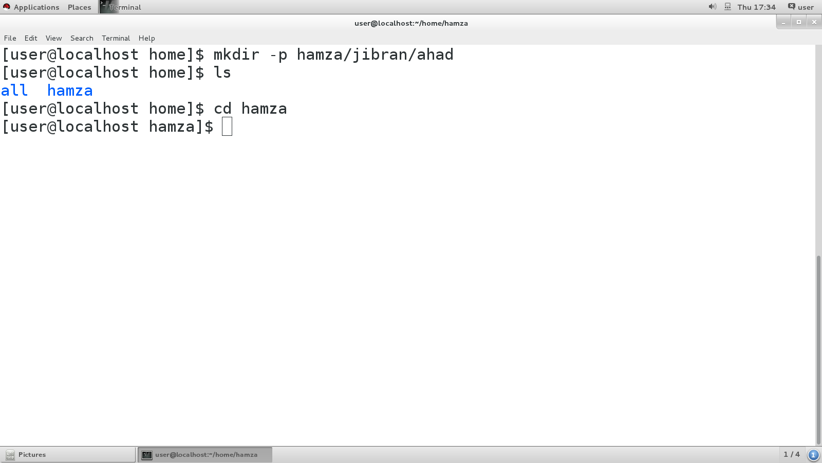

**rm –v all command:**

This command is used to remove all the files of all extensions having same.

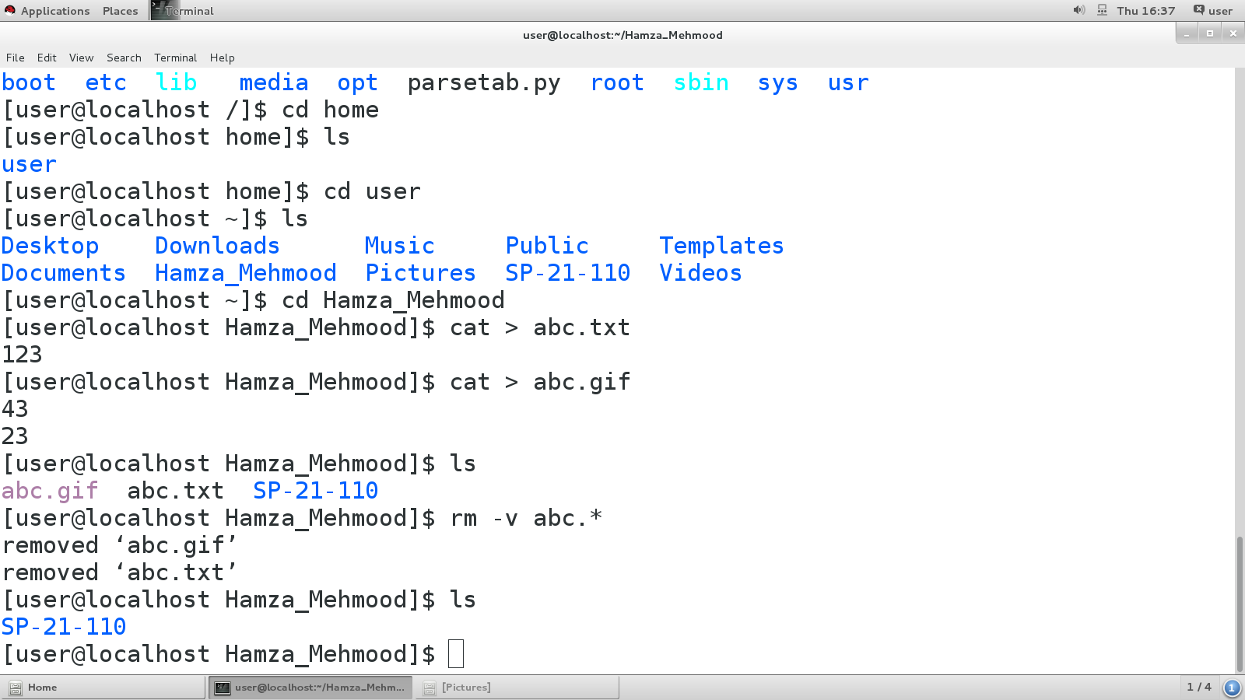

**Creates Old File command:**

This command is used to create the existing file to .old extension..

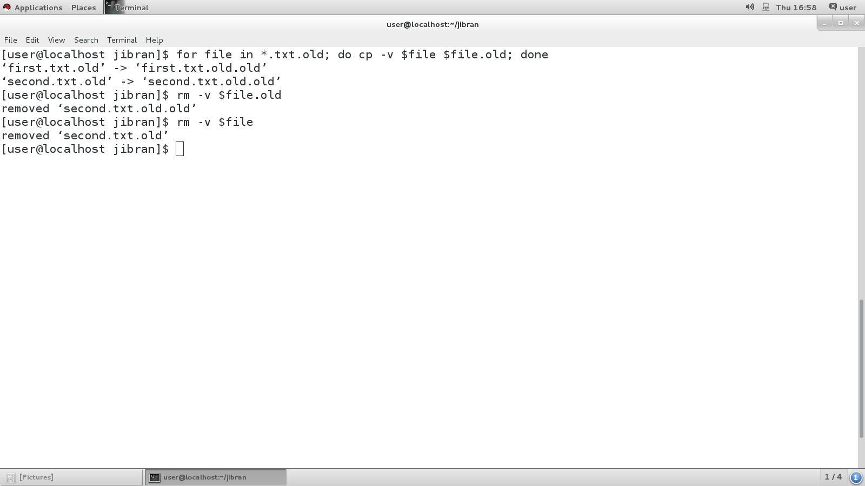

**Moving All Directories to New Directory command:**

This command is used to move the Directories into New Directory.

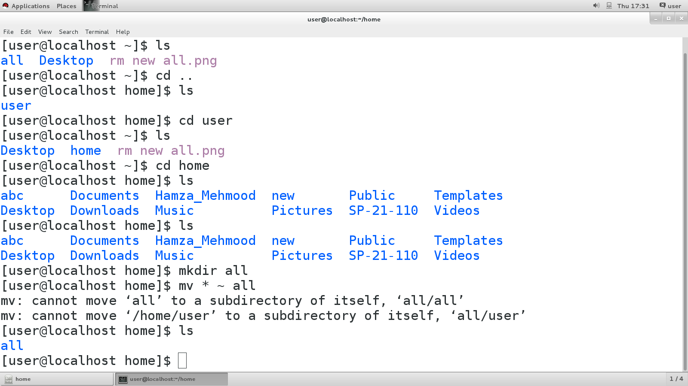

**Copy Files to New Directory command:**

This command is used to Copy Files into the into New Directory.

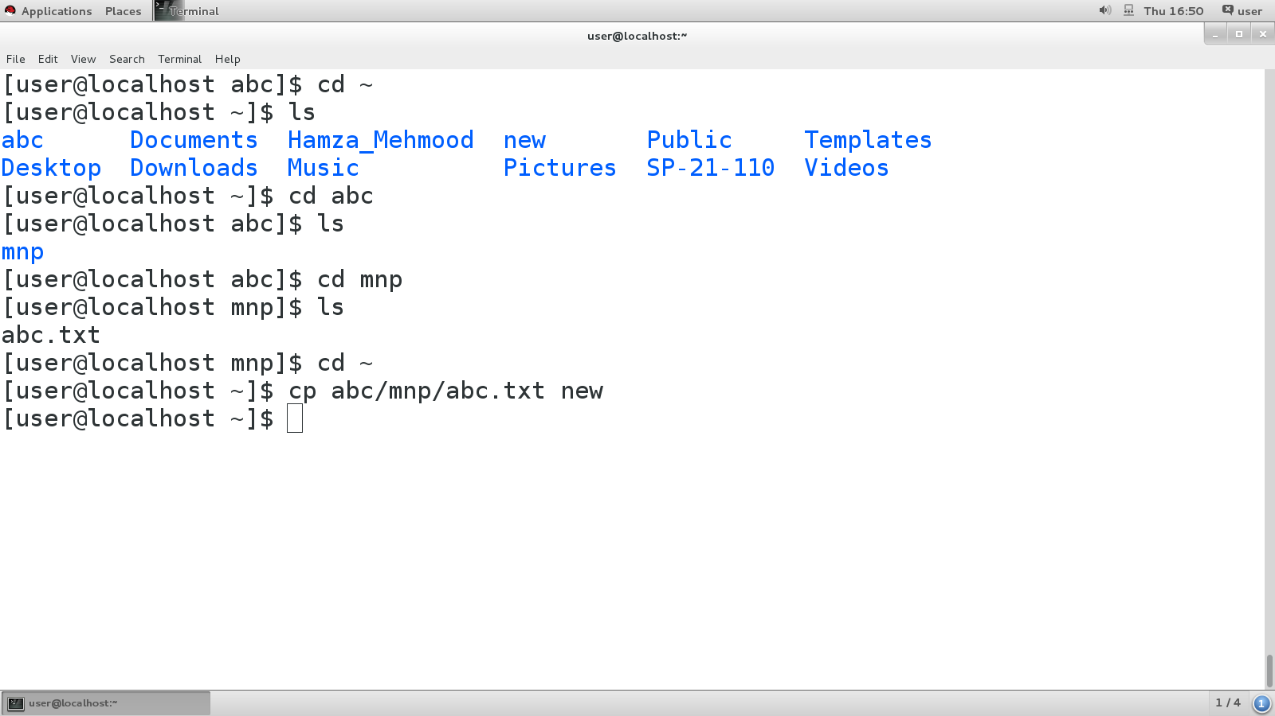

**Copy Files of Differnent Extensions to New Directory command:**

This command is used to Copy all Files of Different Extensions into the into New Directory.

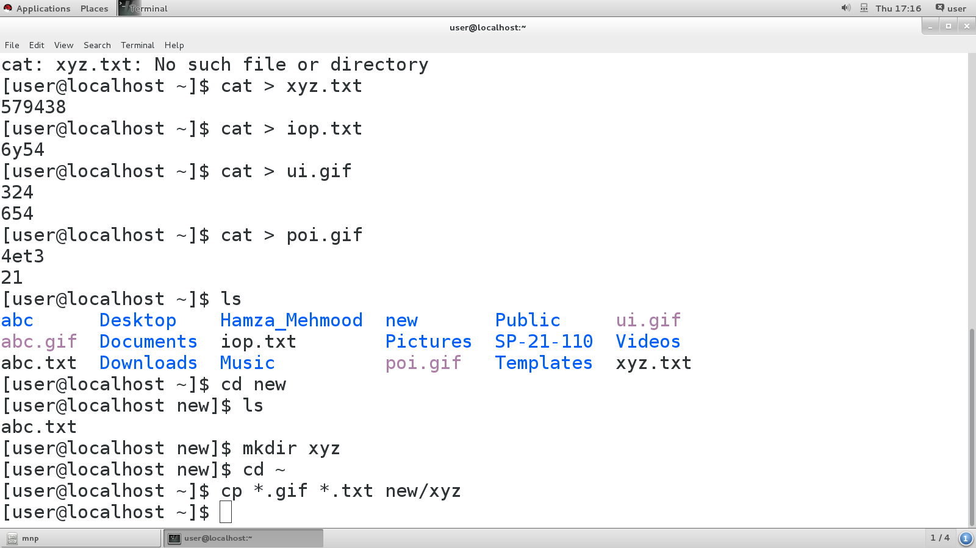

**Rm –rf /new command:**

This command is used to Force Delete all Files in the Root Directory.

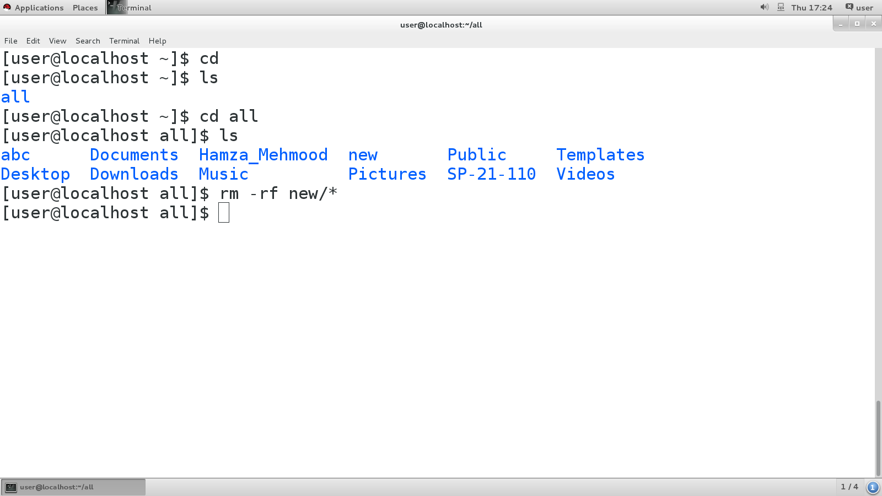

**Adding OLD Extension command:**

This command is used to add .old extension in Files.

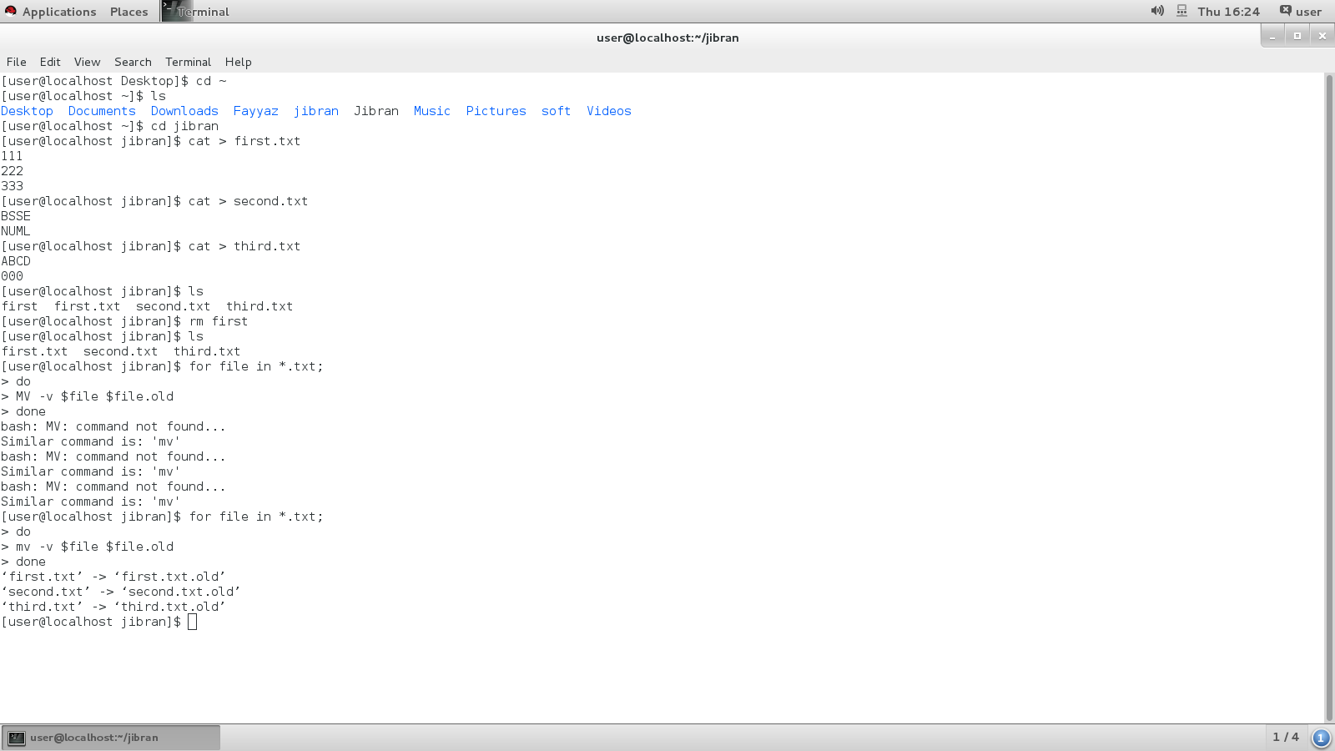

**Time Modify command:**

This command is used to Modify the Time Creation of Files.

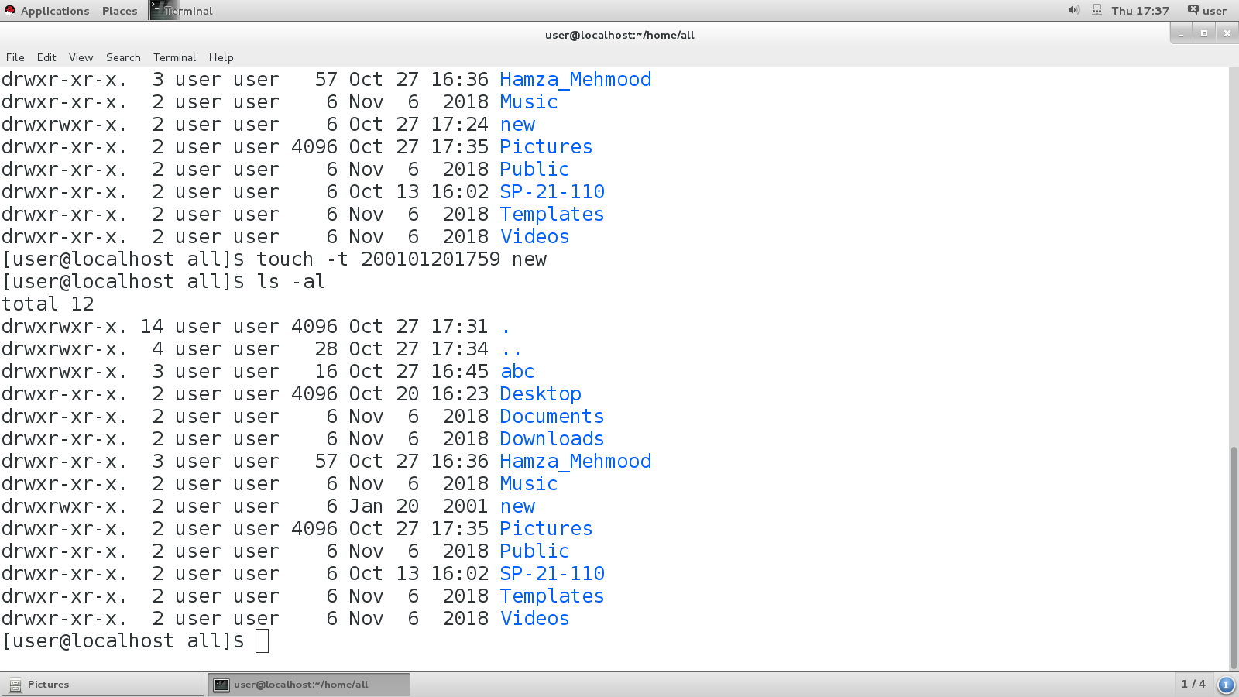

# LAB 7

**echo “LETS COUNT WORDS” | wc command:**

This command is basically used to count the words or letters length which we write in inverted commas. When we run the command the three rows are shown. First will tell the total words then second will tell the length of words and last one tell us the syntax length.

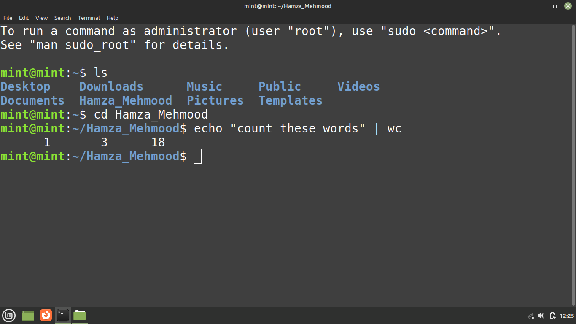

**Less command:**

Less command is a linux utility that can be used to read the contents of a text file one page (one screen) at a time. It has faster access because fi file is large it doesn’t access the complete file, but accesses it page by page.

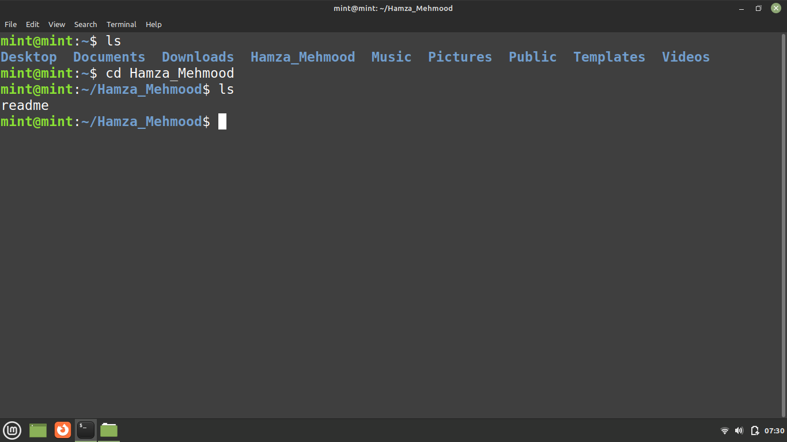

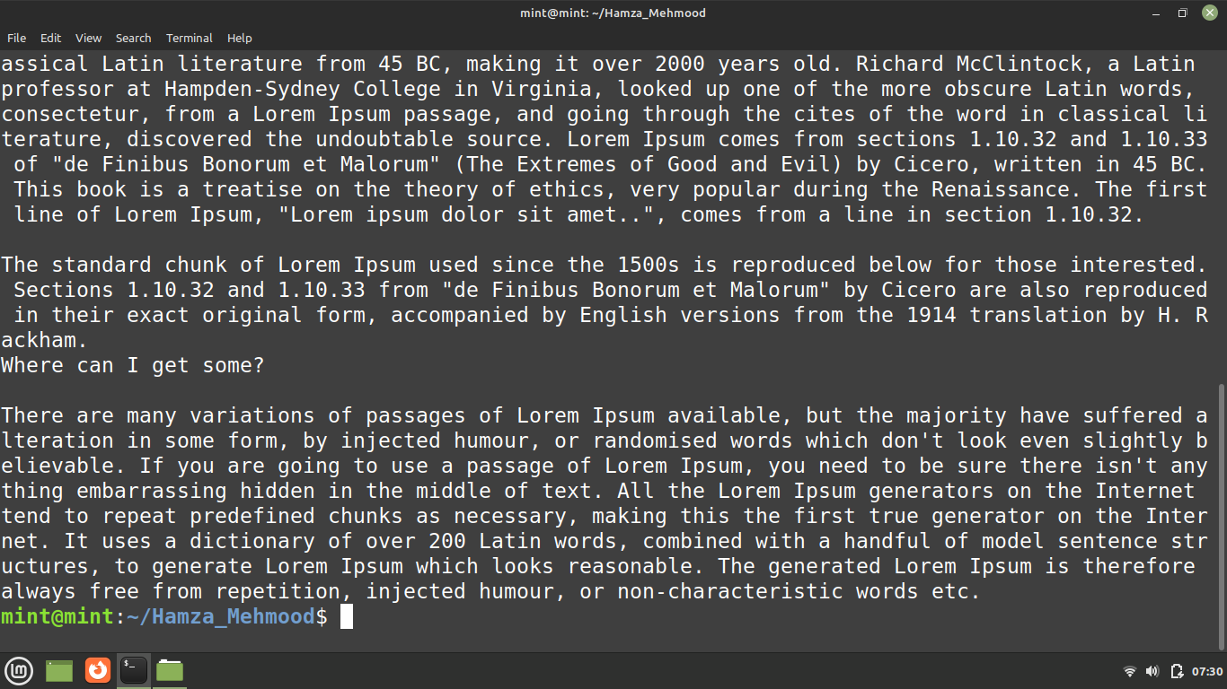

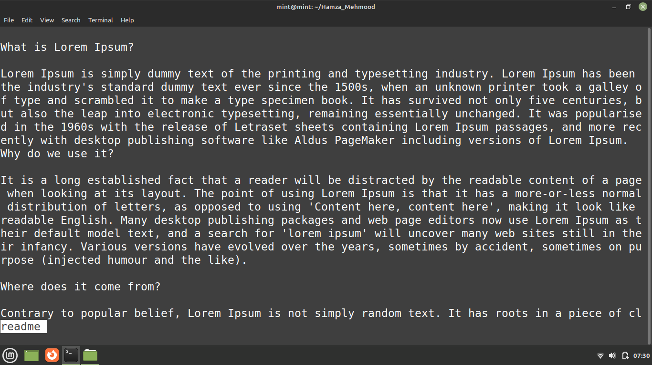

# LAB 8

**sort –f Capital.txt > sorted_capital command:**

Run a command as “sort –f xmg > sorted_xmg” which creates a file with name “sorted_xmg” which stores the sorted form of values we store in xmg file.

And display the sorted values in file using “cat sorted_xmg” command.

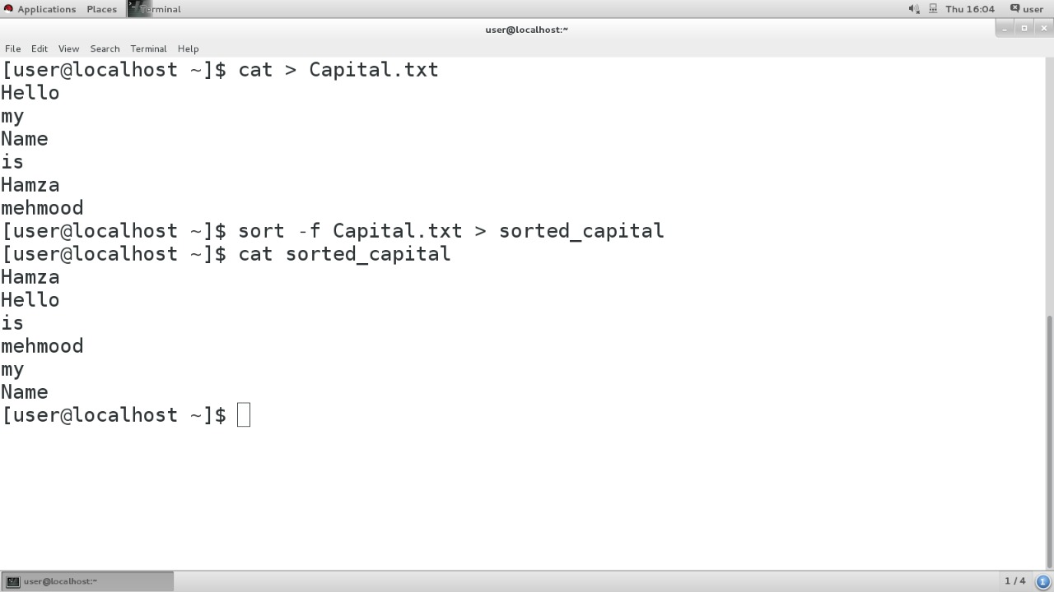

**sort smg > sorted_smg command:**

Using command “sort smg > sorted_smg” to sort the words or characters alphabetically by line.

And display the sorted words or characters in file using “ cat sorted_smg” command.

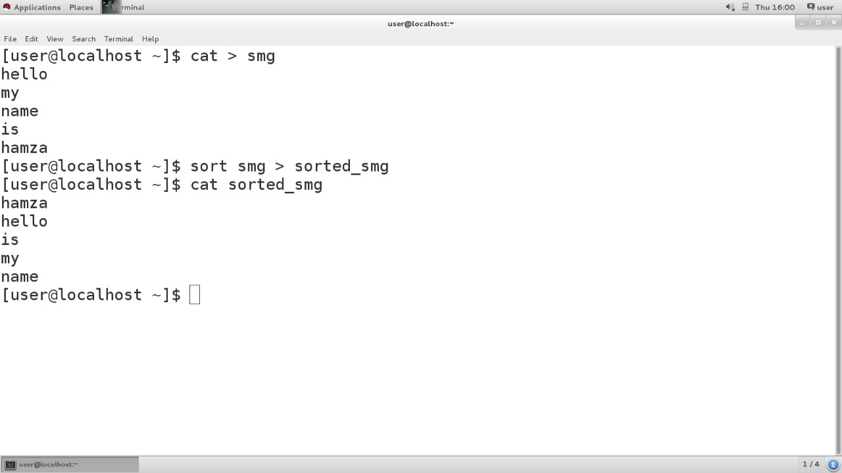

**sort –n numbers.txt > sorted-numbers command:**

using this command we sort the numbers in assending order.

And display the sorted file using “ cat sorted-numbers” command.

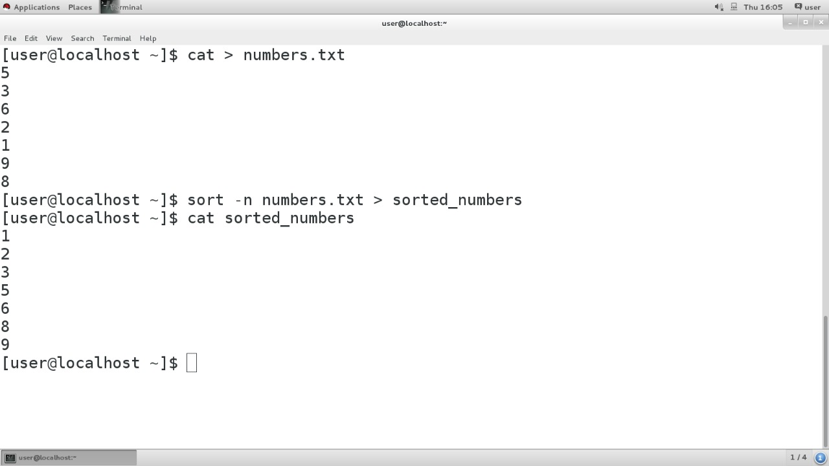

**sort un |uniq| wc -w command:**

this command counts the words and display them this comand do not count duplicate words.

Like here it does’nt count “I am a good boy” 2 times.

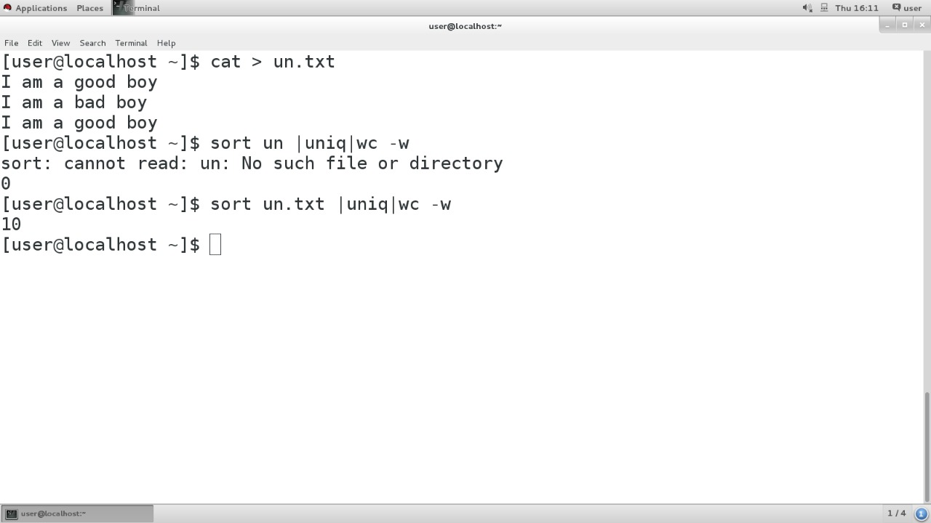

**wc –w eassy.txt command:**

this command counts lines and display numbers of lines.

**wc –c eassy.txt command:**

this command counts total numbers of letters stored in file.

**wc –l eassy.txt command:**

this command is same as “wc –w eassy.txt” command and counts numbers of lines.

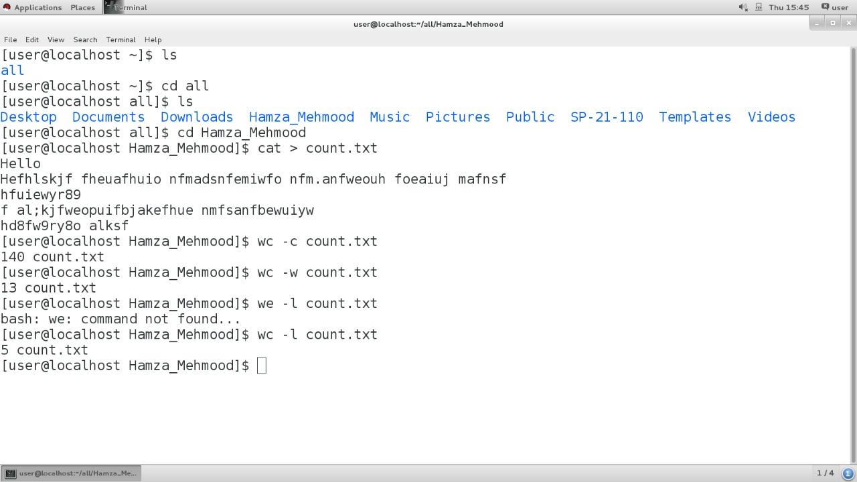

# LAB 9

**Task #1**

Create a file using cat command and run **cat mpg.txt | paste - -** command to do uniform spacing.

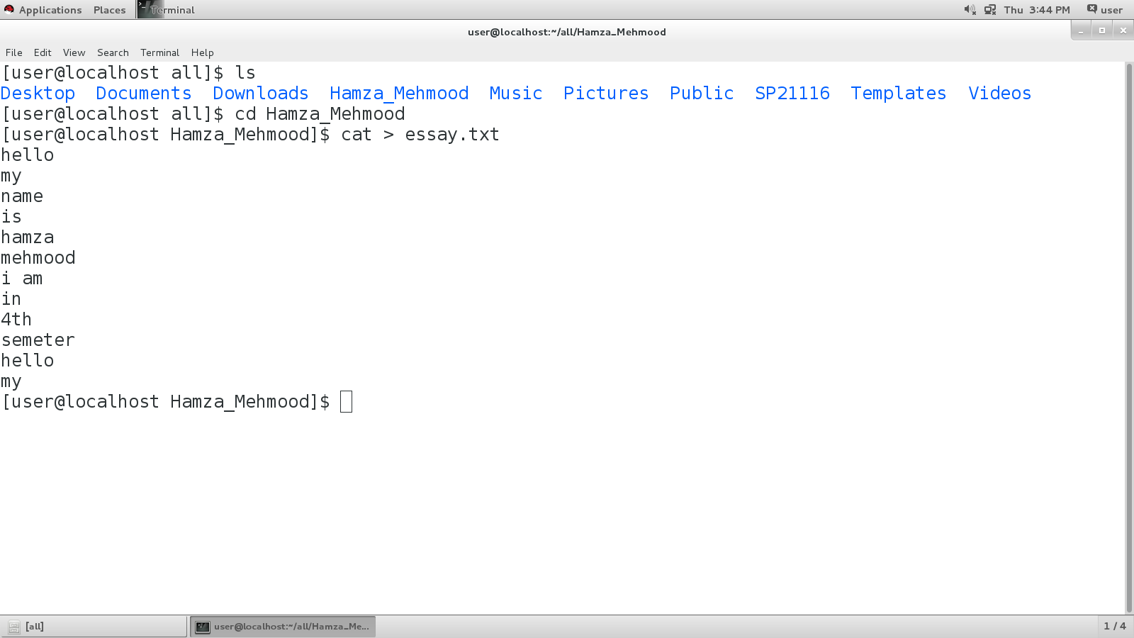

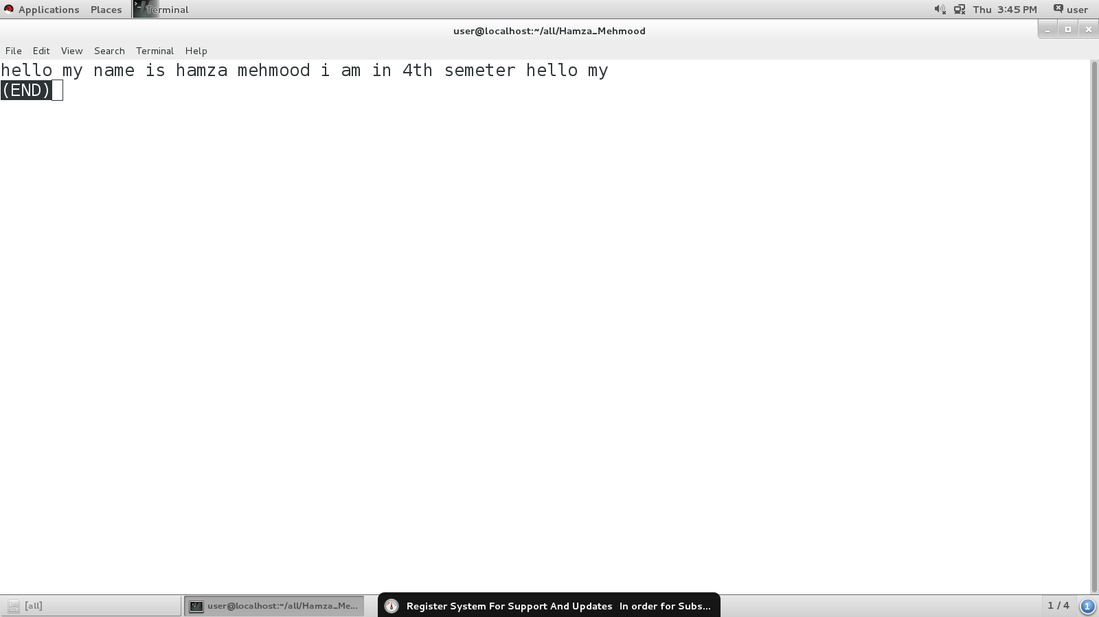

**Task #2**

create 2 files named abc.txt and mpg.txt and run command **pfmt –w 5 para.txt | less displays** words per line

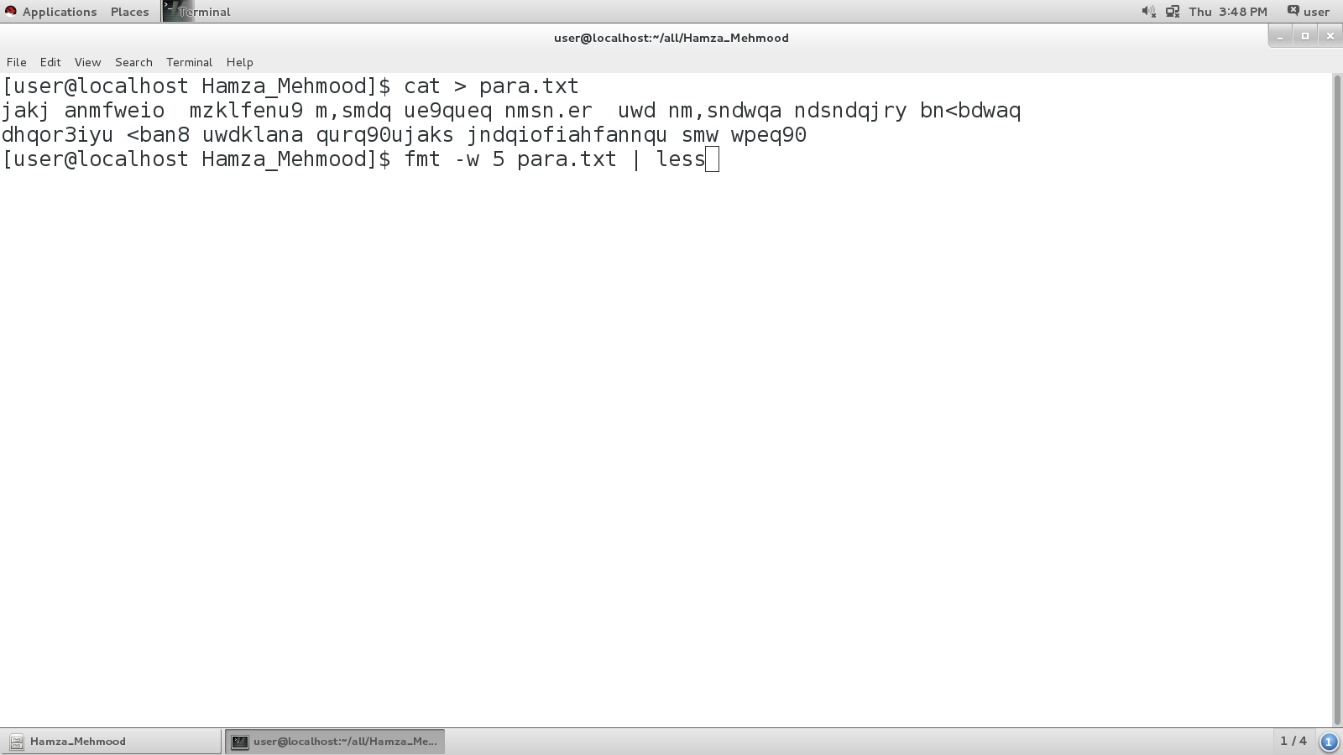

**Task #3**

In this task **head –n l eassy.txt** will display first line.

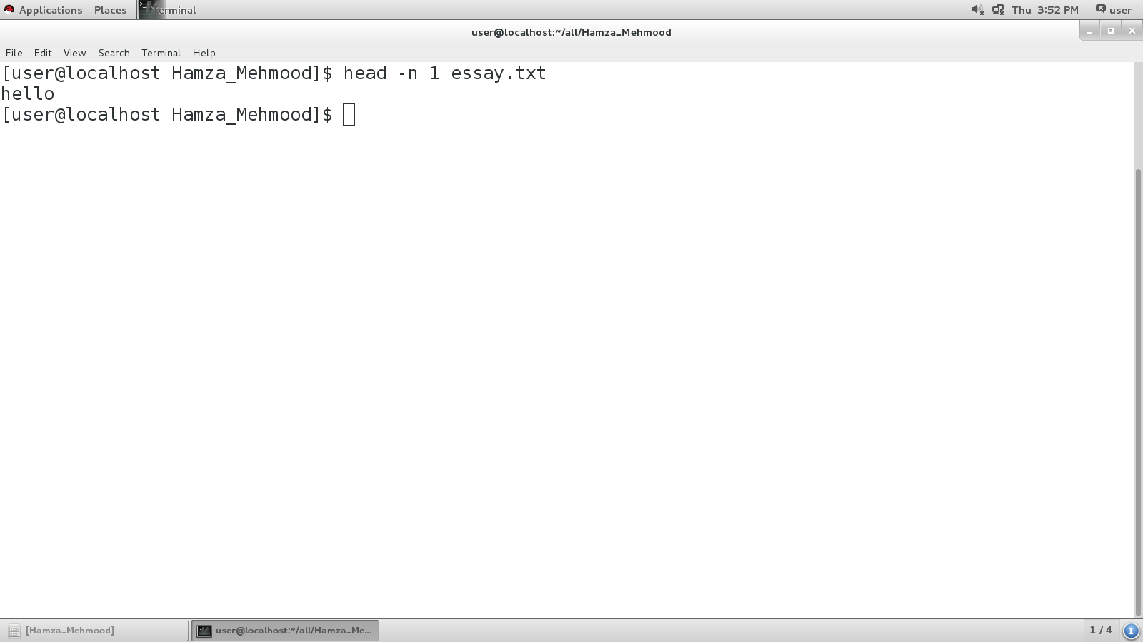

**Task #4**

In this task **tail –n l eassy.txt** will display last line.

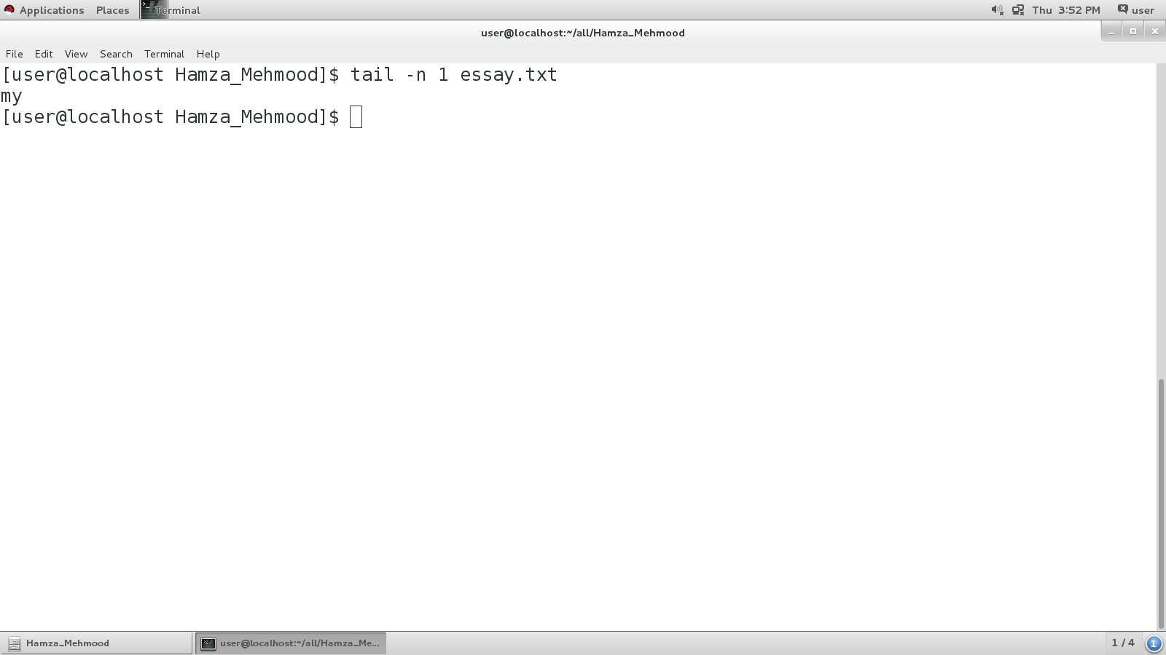

**Task #5**

Create a file and write some name in it then use **cat –b essay.txt**  command it will show line numbering.

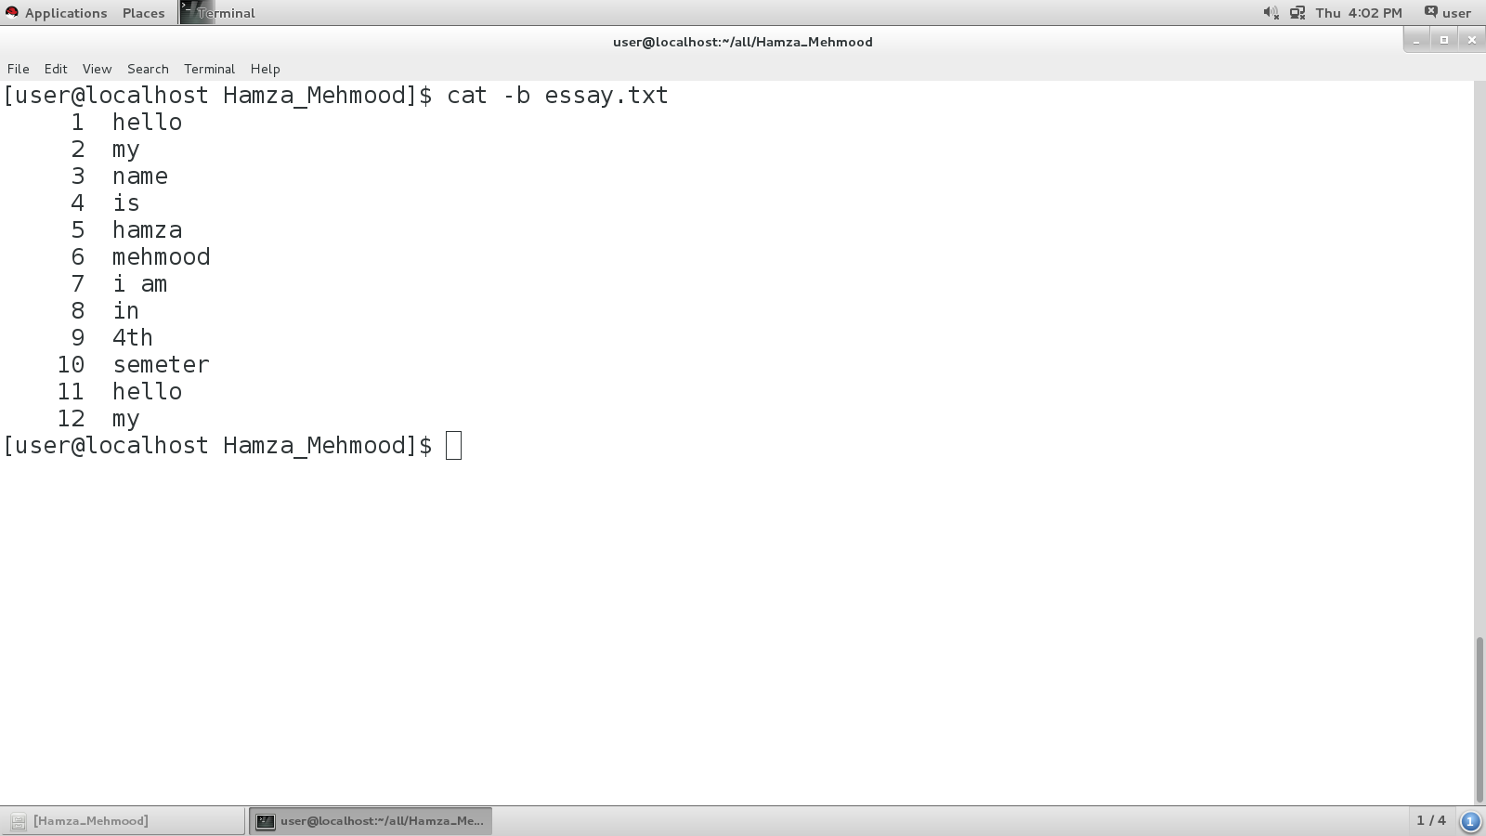

**Task #6**

Craete a file with  **cat** command and write some content. Use **cat –n essay.txt** will sho empty spaces.

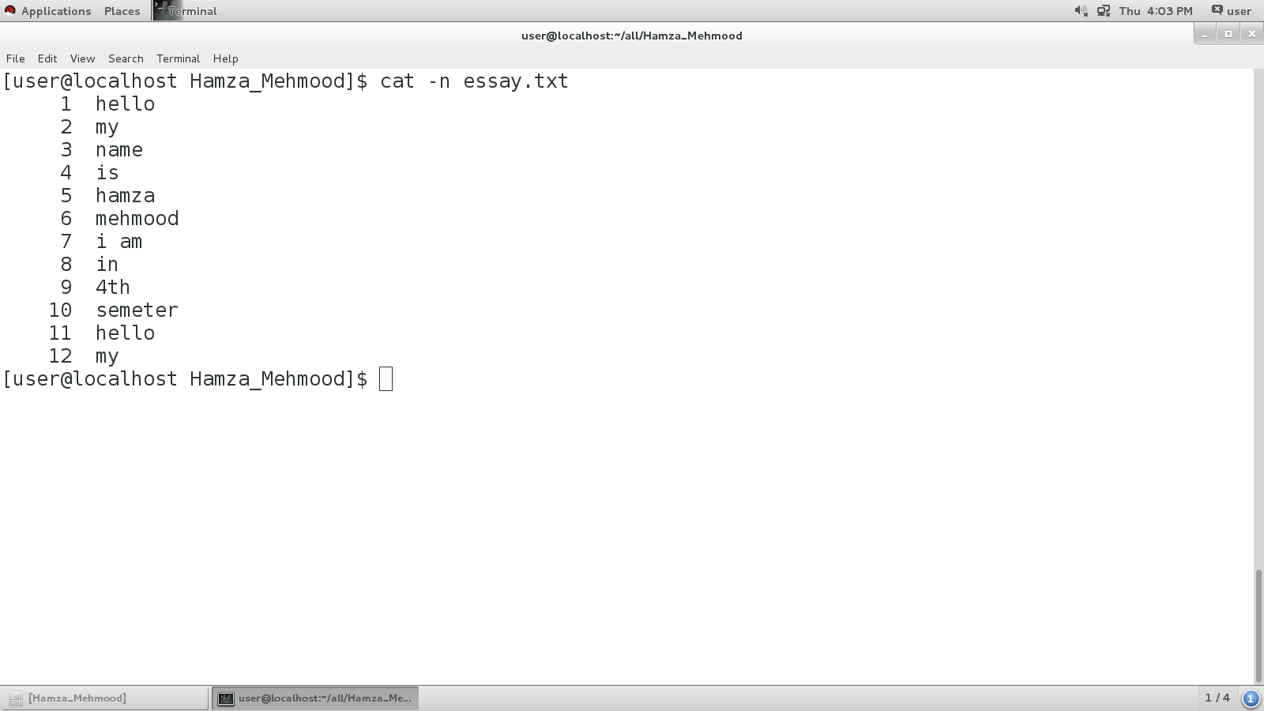

**Task #7**

Make 2 files with cat and save some content in them. Use **split -7 essay.txt shout_** command and it will split the content of both files in list form.

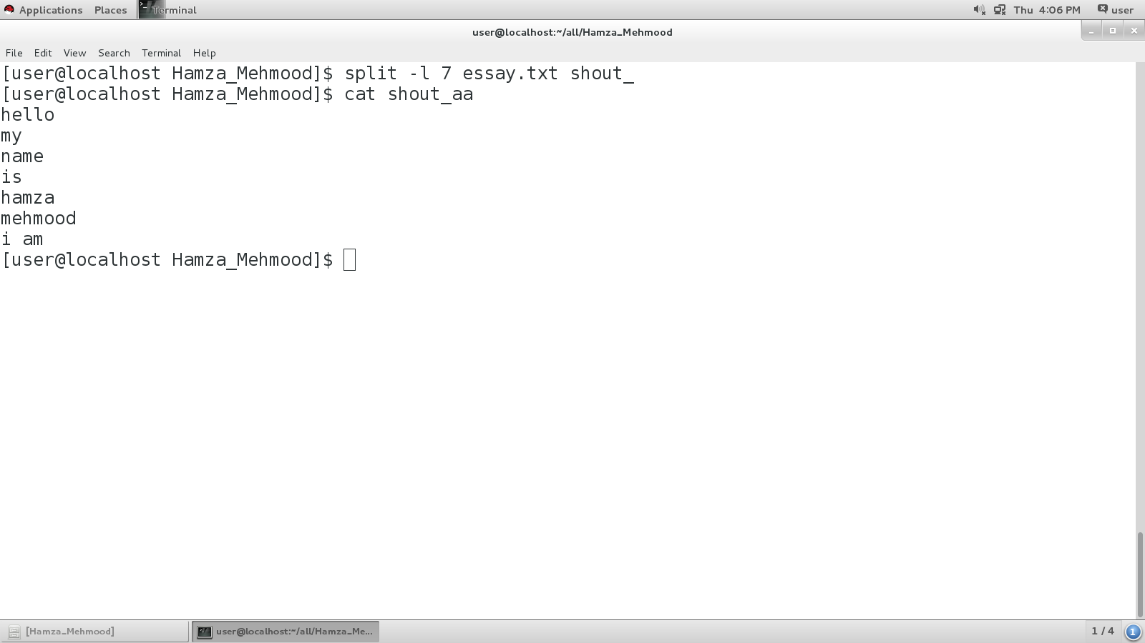

**Task #8**

**Tac essay.txt**  will reverse the file.

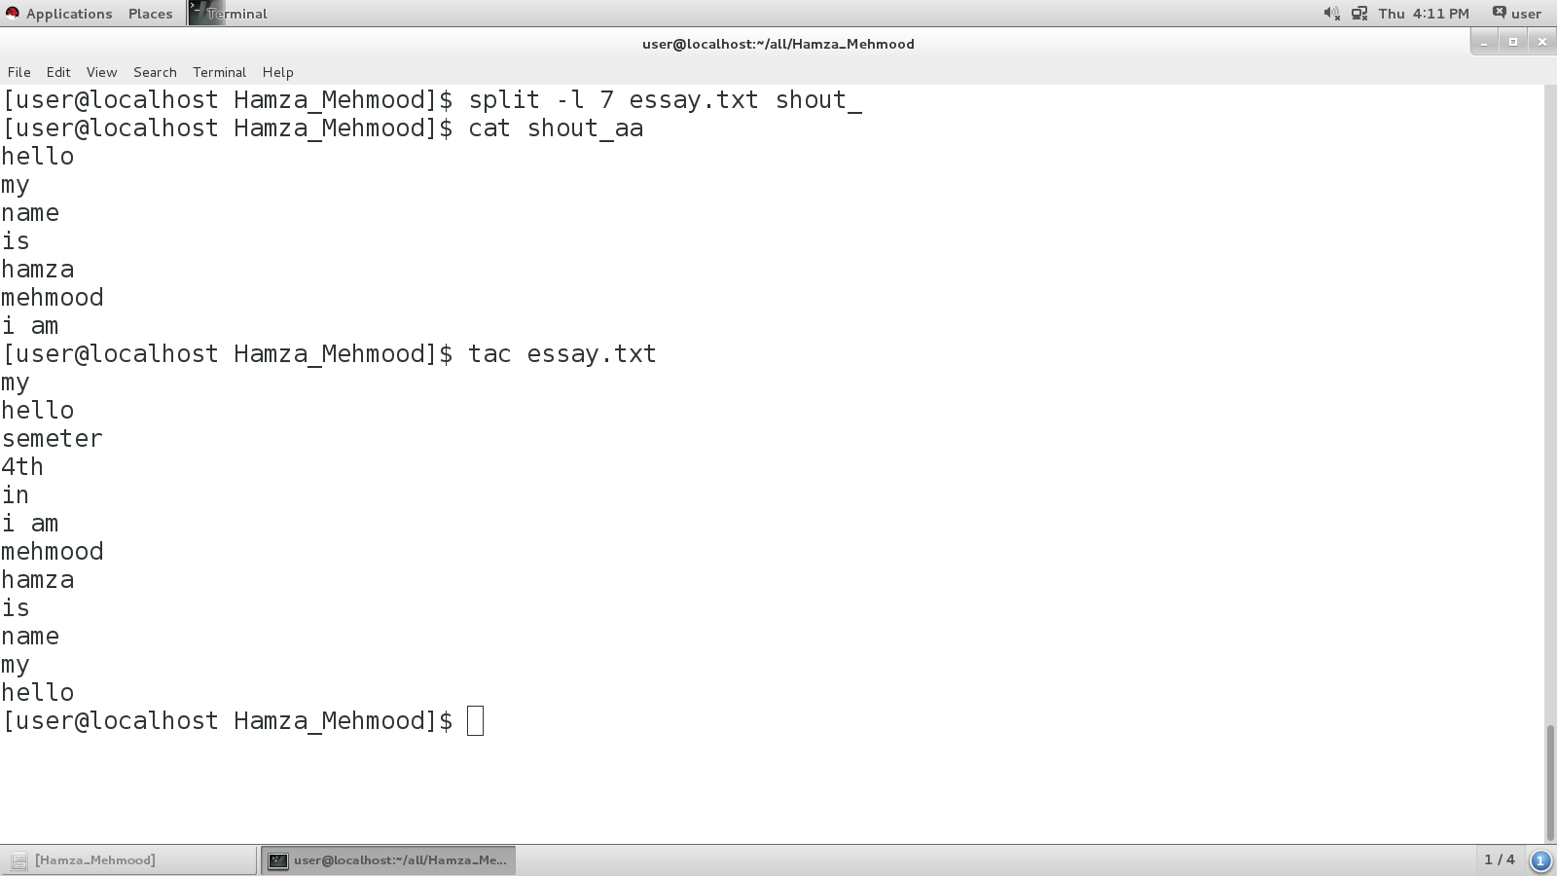

**Task #9**

**paste essay.txt**  will join two files.

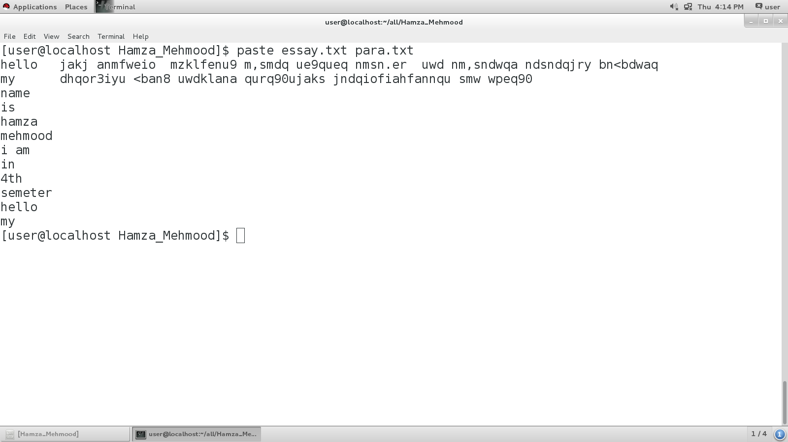

**Task #10**

**This command**  will split two files.

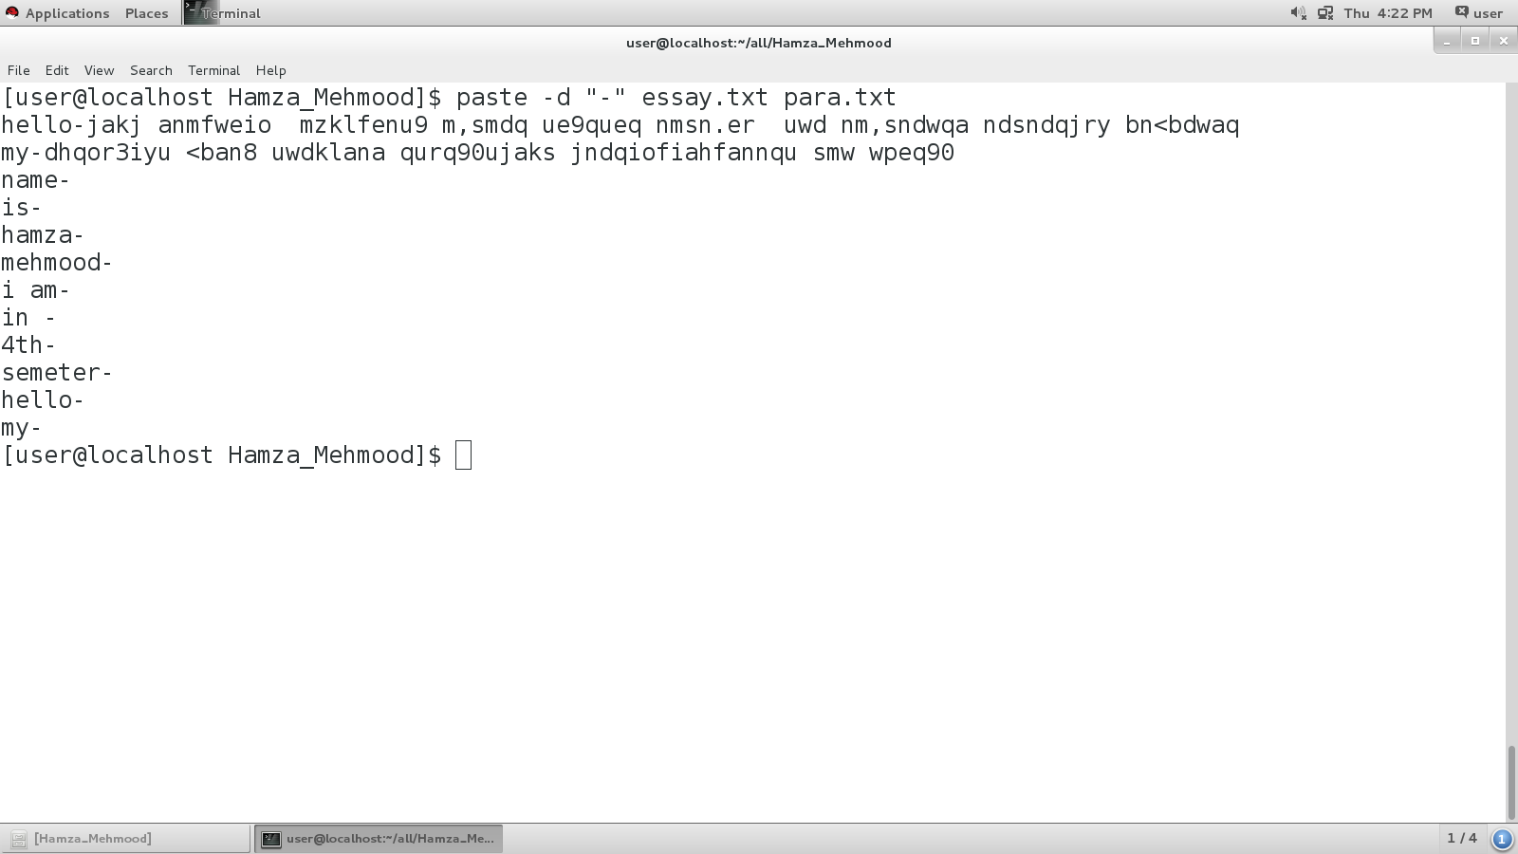

**Task #11**

**Cat shout_aa | paste**  will merge lines.

